Implementation Plan for Settlement Distribution Scheme

Purpose

The Settlement Distribution Scheme is established to give effect to the settlement of Prygodicz & Ors vs the Commonwealth (‘Robodebt’ (Social Security Debt Collection) class action), subject to the agreement of the Federal Court, by distributing to eligible and entitled Group Members the settlement amount of $112 million less legal fees as determined by the court. The scheme will:
- categorise the debts of Group Members to identify those eligible for a settlement payment and those who are not;
- find and notify Group Members of their eligibility for a settlement payment; and
- calculate and distribute settlement payments.
The Settlement Deed requires the Commonwealth to appoint a Scheme Assurer to provide independent assurance over the Settlement Distribution Scheme.
The purpose of this Implementation Plan is to outline the planned approach that Services Australia (the agency) will take in meeting its obligations to implement the Settlement Distribution Scheme as defined in the Settlement Deed, including that all distributions be made no later than 12 months after the date of the Approval Order. Dates contained in the plan are forecasts and may vary subject to the decisions of the Court and contingencies of implementation.

Implementation

Phase 1:

Step 1.1 Categorisation of Group Members’ Debts
- The purpose of categorisation is to identify Group Members eligible for a settlement payment and those who are not.
- A Group Member shall be taken to be ‘eligible’ where:
  - They were attributed at least one income compliance program debt for which a settlement payment may be paid.
- The agency will complete:
  - Identification and categorisation of Group Members consistent with the process in Attachment B.
- The categorisation will be completed by the Federal Court approval hearing, currently scheduled for 6 May 2021.

Customer Categorisation - Eligible for Settlement Distribution
Category Two | Group Members whose debts were wholly or partially based on averaged ATO income information and had made a repayment towards those debts. | These Group Members will receive a settlement distribution payment.  This payment is in addition to the refund that these Group Members have received under the Government’s announcement of 29 May 2020.
Category Three  (Eligible Category 3) | Group Members whose debts were initially based on averaged ATO income information, but then were recalculated using payslips or bank statements, and had overpaid the recalculated debt. | These Group Members will receive a settlement distribution payment in respect of the overpaid amount of their recalculated debt, whether the overpayment was refunded or applied to pay a valid debt.  This Group will not receive an additional refund under the Government’s announcement of [29 May 2020] as any original overpayment would have been refunded at the time of recalculation.

Customer Categorisation - Not Eligible for Settlement Distribution
Category One | Group Members whose debts were based on averaged ATO data and have made no repayments. | These Group Members will have their averaged debt zeroed.  These Group Members will not receive a refund, or a settlement distribution payment.
Category Three  (Ineligible Category 3) | Group Members whose debts were initially based on averaged ATO income information, but then were recalculated using payslips or bank statements, and had not overpaid the recalculated debt. | These Group Members will not receive a refund or a settlement distribution payment.
Category Four | Group Members whose debts were not based on averaged ATO income information. | These Group Members will not receive a refund or a settlement distribution payment.

Step 1.2: Provide random sample to Scheme Assurer
- By 5 March 2021, the Scheme Assurer is to advise the agency of the methodology to be applied to select a random, statistically significant sample of customer records for assurance of the categorisation process.
- By 3 June 2021 or 7 days after court approval orders, whichever is later, the agency shall provide the Scheme Assurer with the random sample of the categorised cohort using the method specified by the Scheme Assurer.
- The Scheme Assurer’s assessment of the categorisation process may commence at the earliest opportunity. Subject to the methodology advised by the Scheme Assurer, assessment may be conducted concurrent with or subsequent to the agency’s categorisation activities.

Step 1.3: Scheme Assurer provides a report to the agency and Gordon Legal with results
- By 17 June 2021 or 21 days after court approval orders, whichever is later, the Scheme Assurer is to make necessary enquiries and, if required, seek clarification to satisfy themselves regarding the categorisation process.
- By 1 July 2021 or 35 days after court approval orders, whichever is later, the Scheme Assurer is to provide a verification process report to the agency and Gordon Legal regarding the agency’s categorisation of Group Members. The report will include a full analysis of the results of the sample and the results, its assessment of the adequacy of that process and any further steps it considers need to be taken to remedy any errors identified in the process.
- The agency will develop a process to update categorisation in the system where necessary and provide an audit log trace.

Step 1.4: Gordon Legal to confirm satisfaction with categorisation, or otherwise follow the dispute process outlined in the Deed
- Gordon Legal will advise the agency and the Scheme Assurer as to whether it is satisfied or not that Group Members have been correctly categorised within a reasonable timeframe after its receipt of the verification process report.
- Alternatively, if the dispute process is enacted, such that timeframes are impacted, then subsequent timelines for delivery will be moved.

Step 1.5: The agency will process the categorisation file after each of the Scheme Assurer and Gordon Legal have completed their reviews.
Phase 2 cannot commence until step 1.5 is completed.

Phase 2: Category notification, tracing and reminders to Group Members
- Phase 2 will follow the process set out in Annexure A to this Implementation Plan.

Step 2.1: Exclude customers who have opted out
- Customers who are identified by the Court as having opted out of the class action are to be identified in the categorisation file and excluded by the agency from notification letters, payment calculations and settlement payment (if otherwise eligible).

Step 2.2: Categorisation Letter - request to verify contact and bank details

- By 1 June 2021, the agency will provide Gordon Legal with drafts of the notifications, correspondence, website text and call scripts, to be provided to, or produced for Group Members under Phase 2 and, if possible, at Step 3.3. Gordon Legal will advise the agency and the Scheme Assurer as to whether it is satisfied or not with the draft notifications, correspondence, website text and call scripts, and will suggest any amendments within a reasonable timeframe after receipt of each.
- By 19 July 2021 or 8 weeks after finalising notifications, correspondence, website text and call scripts with Gordon Legal, whichever is later, the agency will commence sending a letter to each Group Member (via the customer’s preferred correspondence channel), advising the member of their eligibility (or not) per their categorisation in step 1.5. The letter will detail:
  - How the categorisation of Group Members under the settlement scheme operates.
  - Whether or not the Group Member is eligible for a settlement payment based on their categorisation.
  - The options and timeframe to dispute their categorisation, including the deadline for any such dispute to be raised.
  - The deadline by which eligible Group Members must provide or update their bank details with the agency in order to be entitled to a settlement payment, after which the total debts and customers eligible for a share of the Distribution Sum will be closed, being 1 October 2021 or the date that the Scheme Assurer will finalise consideration of all Tier 2 disputes in Step 2.5, whichever is later.
    - Note: If not eligible for a share of the Distribution Sum, this letter will be the final correspondence in the process for those customers

Step 2.3: Web Portal and Telephony Help Line
- By 19 July 2021 or 8 weeks after finalising notifications, correspondence, website text and call scripts with Gordon Legal, whichever is later, the agency shall establish a web portal and specialist telephony line to log and manage requests for information and categorisation disputes, and to enable Group Members to record or update contact/bank details. Opening of the web portal and telephony line shall be concurrent with commencement of sending letters at Step 2.2.
- The link to the category dispute process will only be available up to the date the category dispute process ends (Step 2.5 refers).
- The agency will record Group Member contacts through the web portal or telephony line on their customer record.

Step 2.4: Response tracing
- The agency will monitor and record return-to-sender for surface mail and read receipts on MyGov correspondence.
- Any returned mail or no read receipt in MyGov will follow standard agency processes, including checking for updated address details on a customer record and phone calls to the customer to verify address details for returned mail, and sending physical mail to a customer address if MyGov mail is not read.
  - The agency will also provide supporting information on its website.
  - The agency will undertake all reasonable steps to contact Group Members. This may include follow-up letters, SMS nudges, outbound phone calls or a targeted media campaign.

Step 2.5: Dispute process
- The dispute process will be two tiered. Tier 1 will be managed by the agency, and provided via the web portal or help line; Tier 2 is for escalated disputes and will be managed by the Scheme Assurer.
- The time to raise a dispute (Tier 1) shall end on 27 August 2021 or 6 weeks after the agency commences sending the letters defined at Step 2.3, whichever is later.
- Tier 1: Group Members can challenge their categorisation and the categorisation of their debts. The agency shall apply the process used in step 1.1, with all disputes to be resolved within 7 days after closure of time to lodge disputes, or as soon as is reasonably practicable.
  - The agency shall communicate to a Group Member their right to escalate a dispute to the Scheme Assurer.
- Tier 2: If a Group Member is not satisfied with the outcome of a Tier 1 review, they can escalate their complaint to the Scheme Assurer by 10 September 2021 or 2 weeks after the time for Tier 1 disputes ends, whichever is later.
- The Scheme Assurer shall review the categorisation decision made by the Agency, considering and making an independent determination, consistent with the criteria at step 1.1, on each request for review received.
- The Scheme Assurer will finalise consideration of all disputes by 1 October 2021 or 3 weeks after the time for lodgement of Tier 2 disputes ends, whichever is the later.

Step 2.6: The agency will provide a report to the Scheme Assurer and Gordon Legal to demonstrate all reasonable steps have been undertaken to contact Group Members
- The report will be provided by 27 August 2021, or 6 weeks after the agency commences sending the letter defined at Step 2.3, whichever is the later.
- The report will identify the steps that the agency has taken to fulfill its obligations to contact Group Members.

Step 2.7: The registered cohort of Group Members is defined
- By 1 October 2021 or 3 weeks after the time for lodgement of Tier 2 disputes ends, whichever is later, all Group Members with an eligible debt will have been identified. This is the “registered cohort”.

Phase 3 cannot commence until step 2.7 is completed

Phase 3: Assessment, Notification, and Distribution of Entitlements
- Phase 3 will follow the process set out in Annexure A to this Implementation Plan.

Step 3.1: At the end of the cut-off period, assessment of entitlement is calculated for the “registered cohort”
- If not completed at Step 2.3, by 13 August 2021, the agency will provide Gordon Legal with drafts of the notifications, correspondence, website text and call scripts, to be provided to, or produced for Group Members under Phase 3. Gordon Legal will advise the agency and the Scheme Assurer as to whether it is satisfied or not with the draft notifications, correspondence, website text and call scripts, and will suggest any amendments within a reasonable timeframe after receipt.
- Per the Settlement Deed, entitlement to a share of the Distribution Sum is dependent on having a bank account recorded with Centrelink by 1 October 2021 or 3 weeks after the time for lodgement of Tier 2 disputes ends at Step 2.5, whichever is later.
- Category 2 Group Members or Eligible Category 3 Group Members will be considered to have current bank account details if the account:
  - is the bank account in which the Group Member currently receives a social security or Family Tax Benefit payment; or
  - is the bank account in which the Group Member received a social security or Family Tax Benefit payment at the time of the categorisation notification from the agency at step 2.2; or
  - was nominated by a Category 2 Group Member for the purposes of receiving a refund following the Government’s 29 May 2020 announcement; or
  - was otherwise provided in response to the categorisation notification from the agency outlined in step 2.2.
- Calculation of settlement will be by reference to simple interest notionally accrued:
  - for Category 2 Group Members - the amount of money they repaid at the time they repaid that amount in respect of any invalid debt (as per the Declarations);
  - for Eligible Category 3 Group Members - by reference to the part of the amount they repaid at the time that amount was repaid in respect of an invalid debt, and for such time prior to the subsequent recalculation of that debt, which exceeded the total value of the debt when subsequently recalculated, with the system to calculate entitlement for payment.
- The calculation methodology will be:
  - add a standard additional 2 days to the date a refund is made to allow time for refunds to be paid into a bank account;
  - calculate simple interest for all eligible debts (based on dates and repayments made) using the applicable Federal Court pre-judgement interest rates;
  - sum the simple interest payments;
  - divide the available Distribution Sum by the sum of simple interest payments to calculate a scaling factor (multiplier);
  - multiply all simple interest payments by the scaling factor to calculate the final weighted individual settlement distribution payments; and
  - sum the final weighted individual settlement distribution payments to confirm the Distribution Sum will be fully disbursed.

Step 3.2: Assurance of the calculation and settlement distribution to be completed
- By 27 August 2021, the Scheme Assurer is to advise the agency of the methodology to be applied to select a random, statistically significant sample of customer records for assurance of the settlement distribution process. The agency shall provide the Scheme Assurer with the random sample of the settlement distribution cohort using the methodology specified by the Scheme Assurer.
- The Scheme Assurer will review the proposed settlement distribution in step 3.1, and prepare a report to be provided to the agency and Gordon Legal confirming the accuracy of the calculation within a reasonable timeframe. Note: This step cannot commence until step 3.1 is completed.
- Where disbursement of the exact Distribution Sum cannot be mathematically achieved via a scaling factor, the Scheme Assurer will provide assurance that the full Distribution Sum shall be disbursed and that any variation above this amount is the minimum necessary.
- Recalculation of any distribution sums through the dispute process (Step 3.3 refers) will not impact the distribution sums paid to other eligible Group Members.

Step 3.3: Notification to Group Members entitled to a share of the Settlement Sum
- Prior to the payment of the Distribution Sum, the agency will notify Group Members (via their preferred correspondence channel) of the following matters:
- How the categorisation of Group Members under the Settlement Scheme works;
- the amount they will receive;
- the formula by which their entitlement was calculated; and
- the process for an entitled Group Member to query or dispute a matter under the Settlement Distribution Scheme.
- A web portal will be established for entitled Group Members to review their detailed calculation by entitled debt ID.
- The web portal and a telephony line will be available for a period of 60 days from the first day that a notice is issued under Step 3.3, for Group Members to raise a query or dispute.
- The dispute process will be two tiered. Tier 1 will be managed by the agency, and provided via the web portal or help line; Tier 2 is for escalated disputes and will be managed by the Scheme Assurer.
- Tier 1: Group Members can challenge their settlement distribution sum. The agency shall apply the process used in step 3.1, with all disputes to be resolved within 7 days after closure of time to lodge disputes, or as soon as is reasonably practicable.
  - The agency shall communicate to a Group Member their right to escalate a dispute to the Scheme Assurer.
  - The time to raise a dispute (Tier 1) will end 37 days after the final settlement distribution payment is made. This time allows for the 30 days for Gordon Legal to provide information and assistance to the Group Member plus a minimum of seven days for a Group Member to raise a dispute.
- Tier 2: If a Group Member is not satisfied with the outcome of a Tier 1 review, they can escalate their complaint to the Scheme Assurer within seven days of being advised of the Tier 1 dispute outcome. The time to raise a Tier Two dispute will end 51 days after the final settlement distribution payment is made.

Step 3.4 Payment
- The agency will issue standard payments over a 4-week period to the account details on record, or as provided by the Group Member in step 3.1.
- Payments requiring manual processing or tailored servicing will be processed over a 16 week period (where possible). Note: Manual processing may be required for Group Members with special circumstances including, but not limited to, income management, incarceration, or deceased estates.

Step 3.5: Resolution for returned payments
- The agency shall monitor for rejected/returned payments, and undertake all reasonable steps to re-issue payments.

Step 3.6 Final assurance
- Once the agency has dispersed all distributions, the Scheme Assurer will conduct a final assurance process and confirm to the Court that the agency has followed the processes outline in this plan and to the extent possible settlement funds have been distributed in accordance with the Court approved settlement.

ATTACHMENT A: SETTLEMENT DISTRIBUTION SCHEME PROCESS MAP
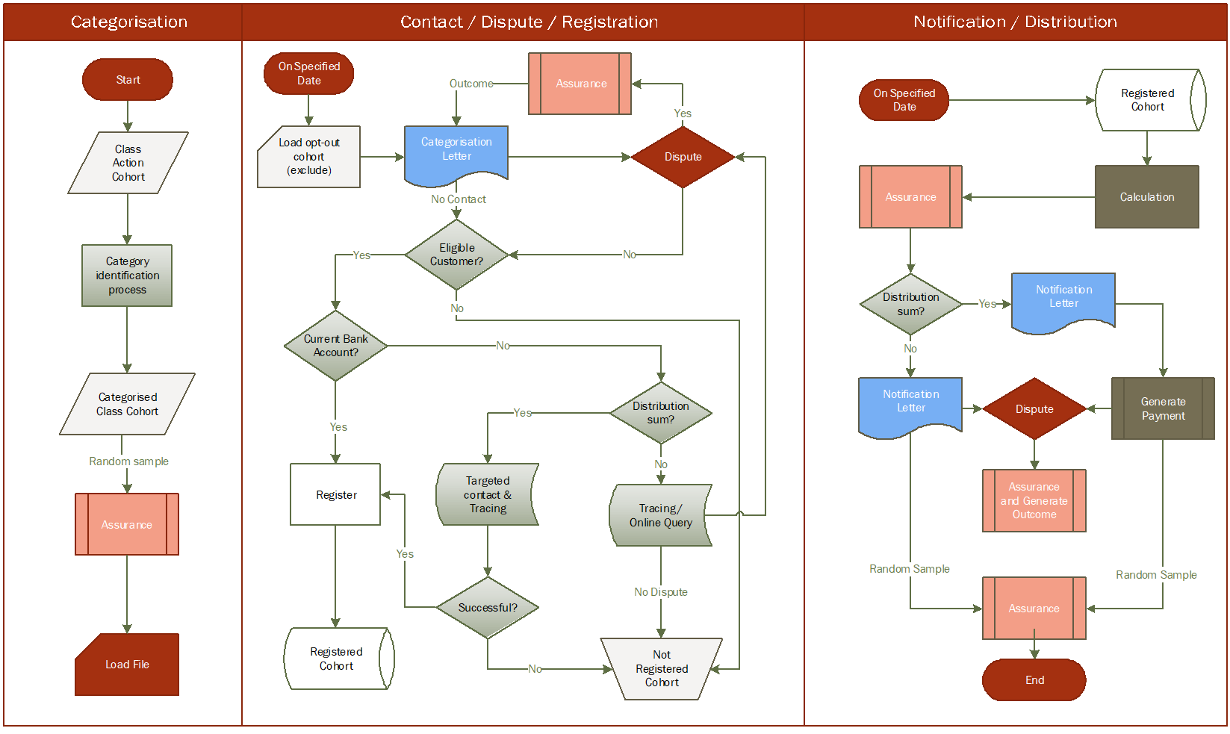

ATTACHMENT B: CATEGORY DECISION TREE
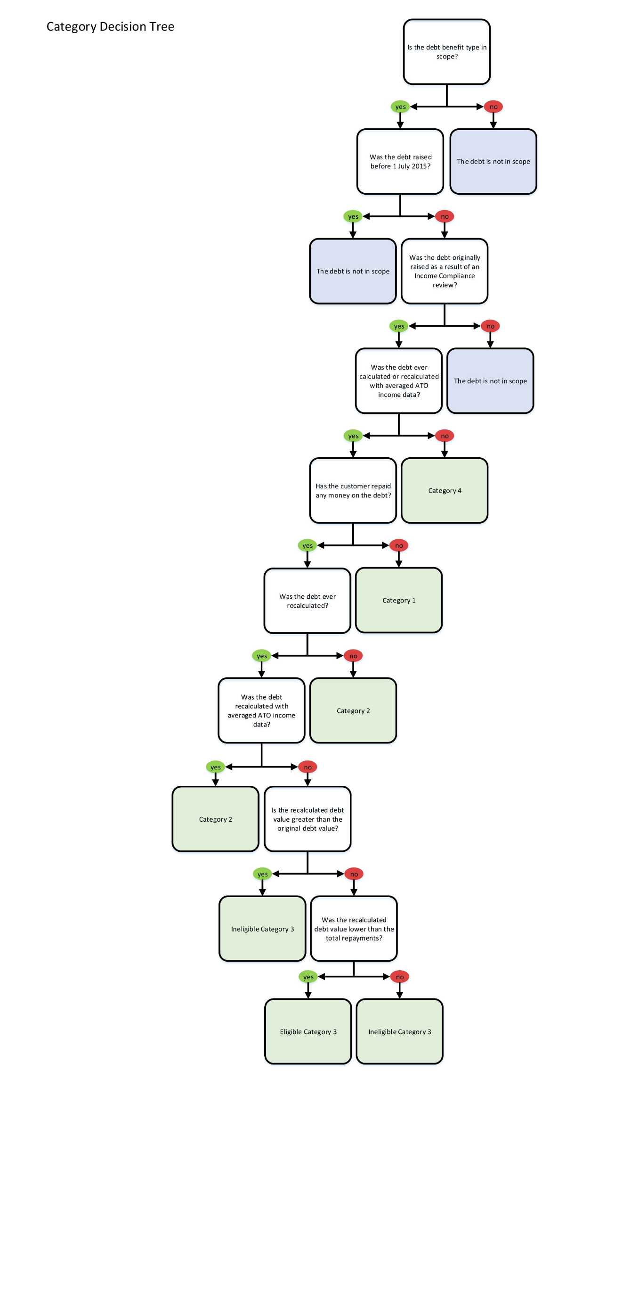

ATTACHMENT C: RISK SUMMARY

The summary below outlines the high level risks to implementation of the agreed settlement of "Prygodicz & Ors vs the Commonwealth" (‘Robodebt’ (Social Security Debt Collection) class action), in accordance with this Implementation Plan.

Risk | Treatment
The Court may direct that the distribution process be varied as part of approving the settlement. | The planned schedule includes sufficient unallocated time to allow for adjustment of the delivery approach to accommodate the Court’s orders.  If the settlement is not approved, the Settlement Distribution Scheme will not be required. If the Court varies the distribution process, the Implementation Plan will be amended to reflect the Court’s requirements.
Incorrect or misleading information on the Settlement Distribution Scheme is available in the public domain, or published through media or social media channels | Development of communication strategy with dedicated communication team support.
Class action Group Members do not understand the settlement distribution process, their eligibility or review rights. | Clear communications to be issued to the class action Group Members.  Dedicated webpage and phone line to be established for settlement enquiries, with consistent scripting and referral protocols provided across the broader agency for customers seeking information through general contact channels.
The categorisation process does not provide the correct outcome for some class action members. | The categorisation process shall be reviewed by the Scheme Assurer, including random sampling to verify accuracy. The Scheme Assurer’s report on categorisation shall be made available to Gordon Legal as the class action Group Members’ legal counsel.  A dispute resolution process shall be established to allow class members to seek review of their categorisation through the agency in the first instance, with a second tier of review by the Scheme Assurer available.
The calculation of settlement payments is not correct. | The calculation process shall be reviewed by the Scheme Assurer, including random sampling to verify accuracy.  Class action Group Members who are entitled to a settlement payment shall be advised in writing prior to payment being made. A dispute resolution process shall be established.
Staff resources initially allocated to the Settlement Distribution Scheme are not sufficient to meet demand. | The agency actively reallocates trained staff to respond to changes in demand.
Development of ICT to support implementation of the Settlement Distribution Scheme does not deliver a suitable product or takes longer than forecast. | The Scheme Assurer to review the ICT system design, build and release to support administration of the scheme.  The planned schedule allows additional time to be allocated to ICT development if required, within the overall time available to implement the Settlement Distribution Scheme.
Class action Group Members with special circumstances require additional support. | A tailored servicing approach will be implemented for customers with special circumstances, including manual processing and direct contact as appropriate. Additional support services such as social worker support shall be made available as needed.

