# Implementation Plan for Settlement Distribution Scheme

## Purpose

The Settlement Distribution Scheme is established to give effect to the settlement of *Prygodicz & Ors vs the Commonwealth* (‘Robodebt’ (Social Security Debt Collection) class action), subject to the approval of the Federal Court, by distributing to eligible Group Members the settlement amount of $112 million less legal fees as determined by the court. The scheme will:

* categorise the debts of Group Members to identify those eligible for a settlement payment and those who are not;
* find and notify Group Members of their eligibility for a settlement payment; and
* calculate and distribute settlement payments.

The Settlement Deed requires the Commonwealth to appoint a Scheme Assurer to provide independent assurance over the Settlement Distribution Scheme.

The purpose of this Implementation Plan (the plan) is to outline the planned approach that Services Australia (the agency) will take in meeting its obligations to implement the Settlement Distribution Scheme as defined in the Settlement Deed. Distribution of the settlement amount through the Settlement Distribution Scheme is to be completed 12 months after the date the Court makes approval orders or the date of completion of the process for Group Members to opt-out from the class action, whichever is later.

Dates contained in the plan are forecasts and may vary subject to the decisions of the Court and contingencies of implementation. The plan provides for 40 weeks to undertake the core work of settlement distribution. This allows for 12 weeks of scheduled contingency, which may be used to extend the time allocated for any individual step within the plan where necessary, to ensure the distribution of funds is completed within the 12 months available.

## Implementation

### Phase 1:

#### Step 1.1 Categorisation of Group Members’ Debts

* The purpose of categorisation is to identify Group Members eligible for a settlement payment and those who are not.
* A Group Member shall be taken to be ‘eligible’ where:
  + They were attributed at least one income compliance program debt for which a settlement payment may be paid.
* The agency will complete:
  + Identification and categorisation of Group Members consistent with the process in **Attachment B**.
* The categorisation will be completed within 7 days of the Court making the settlement approval orders or completion of the opt-out process, whichever is later, and must be completed before step 1.3.

| **Customer Categorisation - Eligible for Settlement Distribution** | | |
| --- | --- | --- |
| **Category Two** | Group Members whose debts were wholly or partially based on averaged ATO income information and had made a repayment towards those debts. | These Group Members will receive a settlement distribution payment.  This payment is in addition to the refund that these Group Members have received under the Government’s announcement of 29 May 2020. |
| **Category Three**  *(Eligible Category 3)* | Group Members whose debts were initially based on averaged ATO income information, but then were recalculated using payslips or bank statements, and had overpaid the recalculated debt. | These Group Members will receive a settlement distribution payment in respect of the overpaid amount of their recalculated debt, whether the overpayment was refunded or applied to pay a valid debt.  This Group will not receive an additional refund under the Government’s announcement of [29 May 2020] as any original overpayment would have been refunded at the time of recalculation. |

| **Customer Categorisation - Not Eligible for Settlement Distribution** | | |
| --- | --- | --- |
| **Category One** | Group Members whose debts were based on averaged ATO data and have made no repayments. | These Group Members will have their averaged debt zeroed.  These Group Members will not receive a refund, or a settlement distribution payment. |
| **Category Three**  *(Ineligible Category 3)* | Group Members whose debts were initially based on averaged ATO income information, but then were recalculated using payslips or bank statements, and had not overpaid the recalculated debt. | These Group Members will not receive a refund or a settlement distribution payment. |
| **Category Four** | Group Members whose debts were not based on averaged ATO income information. | These Group Members will not receive a refund or a settlement distribution payment. |

#### Step 1.2: Provide random sample to Scheme Assurer

* The Scheme Assurer has advised the agency of the methodology to be applied to select a random, statistically significant sample of customer records for assurance of the categorisation process.
* Within 7 days of the Court making the settlement approval orders or completion of the opt-out process, whichever is later, the agency shall provide the Scheme Assurer with the random sample of the categorised cohort using the method specified by the Scheme Assurer.
* The Scheme Assurer’s assessment of the categorisation process may commence at the earliest opportunity. Subject to the methodology advised by the Scheme Assurer, assessment may be conducted concurrent with or subsequent to the agency’s categorisation activities.

#### Step 1.3: Scheme Assurer provides a report to the agency and Gordon Legal with results

* Within 3 weeks of the Court making the settlement approval orders or completion of the opt-out process, whichever is later, the Scheme Assurer is to make necessary enquiries and, if required, seek clarification to satisfy themselves regarding the categorisation process.
* Within 5 weeks of the Court making the settlement approval orders or completion of the opt-out process, whichever is later, the Scheme Assurer is to provide a verification process report to the agency and Gordon Legal regarding the agency’s categorisation of Group Members. The report will include a full analysis of the results of the sample and the results, its assessment of the adequacy of that process and any further steps it considers need to be taken to remedy any errors identified in the process.
* The agency will develop a process to update categorisation in the system where necessary and provide an audit log trace.

#### Step 1.4: Gordon Legal to confirm satisfaction with categorisation, or otherwise follow the dispute process outlined in the Deed

* Gordon Legal will advise the agency and the Scheme Assurer as to whether it is satisfied or not that Group Members have been correctly categorised within a reasonable timeframe after its receipt of the verification process report.
* If Gordon Legal is not satisfied the agency and Gordon Legal shall act in good faith to seek agreement on a resolution within 14 days.
* Alternatively, if the dispute process is engaged, such that timeframes are impacted, then subsequent timelines for delivery will be moved.

#### Step 1.5: The agency will process the categorisation file after each of the Scheme Assurer and Gordon Legal have completed their reviews.

Phase 2 cannot commence until step 1.5 is completed.

### Phase 2: Category notification, tracing and reminders to Group Members

* Phase 2 will follow the process set out in Annexure A to this Implementation Plan.

#### Step 2.1: Exclude customers who have opted out

* Customers who are identified by the Court as having opted out of the class action are to be identified in the categorisation file and excluded by the agency from notification letters, payment calculations and settlement payment (if otherwise eligible).

#### Step 2.2: Categorisation Letter - request to verify contact and bank details

* Within 7 days of the Court making the settlement approval orders or completion of the opt-out process, whichever is later, the agency will provide Gordon Legal with drafts of the notifications, correspondence, website text and call scripts, to be provided to, or produced for Group Members under Phase 2 and, if possible, at Step 3.3. Gordon Legal will advise the agency and the Scheme Assurer as to whether it is satisfied or not with the draft notifications, correspondence, website text and call scripts, and will suggest any amendments within a reasonable timeframe after receipt of each.
* Within 9 weeks of the Court making the settlement approval orders or completion of the opt-out process, whichever is later, and subject to confirmation by Gordon Legal of their satisfaction with draft correspondence as per the above point, the agency will commence sending a letter to each Group Member via the customer’s preferred correspondence channel (MyGov or surface mail).
* The categorisation letter will advise the Group Member of their eligibility (or not) per their categorisation in step 1.5. The letter will detail:
  + How the categorisation of Group Members and their debts operates under the settlement scheme.
  + Whether or not the Group Member is eligible for a settlement payment based on the categorisation of their debts.
  + The options and timeframe to dispute their eligibility for a settlement payment, including the deadline for any such dispute to be raised.
  + The deadline by which those Group Members, who have not already provided to the agency their current bank account details or preferred payment destination as set out at 3.1, must provide that information in order to be entitled to a settlement payment., After this deadline, the total debts and customers eligible for a share of the Distribution Sum will be closed, being the date that the Scheme Assurer will finalise consideration of all Tier 2 disputes in Step 2.5 (21 weeks after court makes the settlement approval orders or completion of the opt-out process, whichever is later.
    - *Note 1: As set out at 3.1, only Group Members, eligible for a share of the Distribution Sum, who are not current customers and have not provided their details to receive a refund following the Government’s 29 May 2020 announcement will need to provide or update their current bank account details or preferred payment destination in response to the categorisation letter.*
    - *Note 2: If not eligible for a share of the Distribution Sum, this letter will advise of the customer’s rights to dispute the process (Tier One). The letter will advise that if the customer is not eligible for a settlement payment and does not dispute the process, the customer will not receive any further correspondence on the matter from the agency.*

#### Step 2.3: Web Portal and Telephony Help Line

* Within 9 weeks of the Court making the settlement approval orders or completion of the opt-out process, whichever is later, the agency shall establish a web portal and specialist telephony line to log and manage requests for information and categorisation disputes and to enable, the cohort of Group Members referred to in Note 1 above, to record or update contact, bank account or preferred payment destination details.
* Opening of the web portal and telephony line shall be concurrent with commencement of sending letters at Step 2.2.
* The link to the category dispute process will only be available up to the date the category dispute process ends (Step 2.5 refers).

The agency will record Group Member contacts through the web portal or telephony line on their customer record.

#### Step 2.4: Response tracing

* The agency will monitor and record return-to-sender for surface mail and read receipts on MyGov correspondence.
* Any returned mail or no read receipt in MyGov will follow standard agency processes, including checking for updated address details on a customer record and phone calls to the customer to verify address details for returned mail, and sending physical mail to a customer address if MyGov mail is not read.
* The following steps to contact the Group Member will be undertaken (in addition to standard agency processes) if the steps at 2.2 are unsuccessful in contacting the cohort of Group Members referred to in Note 1 above and the Group Member has not made contact in accordance with step 2.3:
  + Check the Centrelink details to confirm if details have changed; if details match the returned correspondence details, the following checks will be then undertaken to enable mail to be reissued to an updated address:
    - Check address details stored within other agency databases
    - Check address details stored within other relevant Australian Government databases
    - Check address details stored with External Collection Agencies
    - Once the above steps are exhausted and if no contact is successful – the Group Member will be recorded on a log of failed to contacts held by the agency.
  + Contact attempts will be documented on the Group Members’ customer record.
  + Prior to sending physical mail to an alternative customer address, the agency shall attempt to phone the Group Member to verify the alternative address details for returned mail.
  + Commencing 11 weeks after court makes the settlement approval orders or completion of the opt-out process, whichever is later, the agency will issue a SMS reminder message to all Group Members who have not responded.
  + Commencing 12 weeks after court makes the settlement approval orders or completion of the opt-out process, whichever is later, the agency will issue a final SMS reminder message to Group Members who have not responded. This will be the agency’s final attempt to contact Group Members who have not responded.
  + The agency SMS campaign will be supported by a public communication approach, which includes social media, and radio.
  + The agency will also provide supporting information on its website.

#### Step 2.5: Dispute process

* The dispute process will be two tiered. Tier 1 will be managed by the agency, and provided via the web portal or help line; Tier 2 is for escalated disputes and will be managed by the Scheme Assurer.
* The time to raise a dispute (Tier 1) shall end 15 weeks after court orders or completion of the opt-out process, whichever is later.
* Tier 1: Group Members can challenge their categorisation and the categorisation of their debts. The agency shall apply the process used in step 1.1, with all disputes to be resolved 16 weeks after court makes the settlement approval orders or completion of the opt-out process, whichever is later, or as soon as is reasonably practicable.
  + The agency shall communicate to a Group Member their right to escalate a dispute to the Scheme Assurer.
* Tier 2: If a Group Member is not satisfied with the outcome of a Tier 1 review, they can escalate their complaint to the Scheme Assurer by 2 weeks after the time for Tier 1 disputes ends (18 weeks after court orders or completion of the opt-out process, whichever is later).
* The Scheme Assurer shall review the categorisation decision made by the Agency, considering and making an independent determination, consistent with the criteria at step 1.1, on each request for review received.
* The Scheme Assurer will finalise consideration of all disputes by 3 weeks after the time for lodgement of Tier 2 disputes ends (21 weeks after court orders or completion of the opt-out process, whichever is later), or as soon as is reasonably practicable.

#### Step 2.6: The agency will provide a report to the Scheme Assurer and Gordon Legal to demonstrate all available steps set out in Step 2.4 above have been undertaken to contact Group Members

* The report will be provided by 16 weeks after the Court makes the settlement approval orders or completion of the opt-out process, whichever is later.
* The report will identify the steps that the agency has taken to fulfil its obligations to contact Group Members.
* Gordon Legal will advise the agency and the Scheme Assurer as to whether it is satisfied or not that all available steps set out in Step 2.4 have been undertaken to contact Group Members within a reasonable timeframe after its receipt of the report.
* If Gordon Legal is not satisfied the agency and Gordon Legal shall act in good faith to agree on a resolution within 14 days.
* Alternatively, if the dispute process is engaged, such that timeframes are impacted, then subsequent timelines for delivery will be moved.

#### Step 2.7: The registered cohort of Group Members is defined

* Within 4 weeks after the time for lodgement of Tier 2 disputes ends (22 weeks after court orders or completion of the opt-out process, whichever is later) all Group Members with an eligible debt and a current bank account or preferred payment destination will have been identified. This is the “registered cohort”.

**Phase 3 cannot commence until step 2.7 is completed**

### Phase 3: Assessment, Notification, and Distribution of Entitlements

* Phase 3 will follow the process set out in Annexure A to this Implementation Plan.

#### Step 3.1: At the end of the cut-off period, assessment of entitlement is calculated for the “registered cohort”

* If not completed at Step 2.3, the agency will provide Gordon Legal with drafts of the notifications, correspondence, website text and call scripts, to be provided to, or produced for Group Members under Phase 3 (14 weeks after court orders or completion of the opt-out process, whichever is later). Gordon Legal will advise the agency and the Scheme Assurer as to whether it is satisfied or not with the draft notifications, correspondence, website text and call scripts, and will suggest any amendments within a reasonable timeframe after receipt.
* Per the Settlement Deed, entitlement to a share of the Distribution Sum is dependent on having a bank account or preferred payment destination recorded with the agency within 4 weeks after the time for lodgement of Tier 2 disputes ends at Step 2.5 (22 weeks after court makes the settlement approval orders or completion of the opt-out process, whichever is later).
* Category 2 Group Members or Eligible Category 3 Group Members will be considered to have current bank account details if:
  + the account is the bank account in which the Group Member currently receives a social security or Family Tax Benefit payment; or
  + the account is the bank account in which the Group Member received a social security or Family Tax Benefit payment at the time of the categorisation notification from the agency at step 2.2; or
  + the account was nominated by a Category 2 Group Member for the purposes of receiving a refund following the Government’s 29 May 2020 announcement;
  + the account was otherwise provided in response to the categorisation notification from the agency outlined in step 2.2;
  + the Group Member has otherwise made contact with the agency or been contacted by the agency in accordance with steps 2.3 or 2.4 and has nominated a bank account.
* Category 2 Group Members or Eligible Category 3 Group Members will be considered to have provided a preferred payment destination to the agency in lieu of current bank account details in response to the categorisation notification from the agency outlined in step 2.2 if they:
  + currently receive a social security or Family Tax Benefit payment (i.e. current customers) other than to a bank account, or did so at the time of the categorisation notification at step 2.2;
  + have been paid a refund following the Government’s 29 May 2020 announcement, other than to a bank account;
  + have responded to the notice at step 2.2 nominating a preferred payment destination;
  + have otherwise made contact with the agency or been contacted by the agency in accordance with steps 2.3 or 2.4 and nominated a preferred payment destination.
* Calculation of settlement will be by reference to simple interest notionally accrued:
  + for Category 2 Group Members - the amount of money they repaid at the time they repaid that amount in respect of any invalid debt (as per the Declarations);
  + for Eligible Category 3 Group Members - by reference to the part of the amount they repaid at the time that amount was repaid in respect of an invalid debt, and for such time prior to the subsequent recalculation of that debt, which exceeded the total value of the debt when subsequently recalculated, with the system to calculate entitlement for payment.
* The calculation methodology will be:
  + add a standard additional 2 days to the date a refund is made to allow time for refunds to be paid into a bank account;
  + calculate simple interest for all eligible debts based on the amount of money repaid and the length of time it was held by the Commonwealth, calculated daily using the Federal Court pre-judgement interest rates that apply from time to time during the debt periods;
  + sum the simple interest payments;
  + divide the available Distribution Sum by the sum of simple interest payments to calculate a scaling factor (multiplier);
  + multiply all simple interest payments by the scaling factor to calculate the final weighted individual settlement distribution payments; and
  + sum the final weighted individual settlement distribution payments to confirm the Distribution Sum will be fully disbursed.
* The agency shall apply rounding to the calculation of individual settlement distribution payments, and shall round up to the next whole cent (for example: $70.0312 rounds up to $70.04).

#### Step 3.2: Assurance of the calculation and settlement distribution to be completed

* Within 7 days after the registered cohort have been identified (23 weeks after the Court makes the settlement approval orders or completion of the opt-out process, whichever is later), the Scheme Assurer is to advise the agency of the methodology to be applied to select a random, statistically significant sample of customer records for assurance of the settlement distribution process. The agency shall provide the Scheme Assurer with the random sample of the settlement distribution cohort, using the methodology specified by the Scheme Assurer.
* The Scheme Assurer will review the proposed settlement distribution in step 3.1, and prepare a report to be provided to the agency and Gordon Legal confirming the accuracy of the calculation within a reasonable timeframe. **Note: This step cannot commence until step 3.1 is completed.**
* Where disbursement of the exact Distribution Sum cannot be mathematically achieved via a scaling factor, the Scheme Assurer will provide assurance that the full Distribution Sum shall be disbursed and that any variation above this amount is the minimum necessary.
* Recalculation of any distribution sums through the dispute process (Step 3.3 refers) will not impact the distribution sums paid to other eligible Group Members.

#### Step 3.3: Notification to Group Members entitled to a share of the Settlement Sum

* Prior to the payment of the Distribution Sum, the agency will notify Group Members (via their preferred correspondence channel) of the following matters:
* How the categorisation of Group Members under the Settlement Scheme works;
* the amount they will receive;
* the formula by which their entitlement was calculated; and
* the process for an entitled Group Member to query or dispute a matter under the Settlement Distribution Scheme.
* A web portal will be established for entitled Group Members to review their detailed calculation by entitled debt ID.
* The web portal and a telephony line will be available from the first day that a notice is issued to 48 weeks after Court makes the settlement approval orders or completion of the opt-out process, whichever is later, for Group Members to raise a query or dispute.
* The dispute process will be two tiered. Tier 1 will be managed by the agency, and provided via the web portal or help line; Tier 2 is for escalated disputes and will be managed by the Scheme Assurer.
* Tier 1: Group Members can challenge their settlement distribution sum. The agency shall apply the process used in step 3.1, with all disputes to be resolved within 7 days after closure of time to lodge disputes, or as soon as is reasonably practicable.
  + The agency shall communicate to a Group Member their right to escalate a dispute to the Scheme Assurer.
  + The time to raise a dispute (Tier 1) will end 30 days after the settlement distribution payment is made to the Group Member.
* Tier 2: If a Group Member is not satisfied with the outcome of a Tier 1 review, they can escalate their complaint to the Scheme Assurer within seven days of being advised of the Tier 1 dispute outcome. The time to raise a Tier Two dispute will end 51 days after the settlement distribution payment is made to the Group Member.
* Gordon Legal will perform the limited role of providing, to those Group Members who request it, information and assistance about the Settlement Distribution Scheme from the date the Court makes the settlement approval orders to the date being 51 days after each Group Member receives their share of the Distribution Sum. The scope of such information and assistance remains limited in accordance with Clause 5 of the Framework of Settlement Distribution Scheme.

#### Step 3.4 Payment

* The agency will issue the majority of payments over a 4-week period to the account details on record, or as provided by the Group Member in step 3.1, from 32 weeks after Court makes the settlement approval orders or completion of the opt-out process, whichever is later.
* Some Group Members will require manual processing or tailored serving due to the complexity or sensitivity of their individual circumstances.
* Payments requiring manual processing or tailored servicing will be processed over a 16 week period (where possible) to cater for complex processing and additional customer support, such as social worker contact or interpreting services   
  *Note: Manual processing and/or tailored servicing may be required for Group Members including but not limited to:*
* *customers with complex Centrelink records*
* *customers with an international bank account*
* *income managed customers*
* *incarcerated customers*
* *rural, remote and indigenous customers, or*
* *deceased estates.*
* The Agency will contact Group Members identified as requiring manual processing and/or tailored servicing at the earliest possible opportunity to advise of their payment timeframe.

#### Step 3.5: Resolution for returned payments

* The agency shall monitor for payments that are rejected or returned by a Group Member’s financial institution, and undertake all reasonable steps to re-issue payments, as described below:
* The agency’s workload management system will flag rejected/returned payments and present them to an agency staff member to manually action rejected/returned payments. The agency staff member will make two attempts to contact the Group Member by phone to get their correct bank account details or preferred payment destination. If unsuccessful, the agency staff member will issue “request for payment destination details” correspondence to the Group Member.
* A Group Member may contact the agency to advise they have not received their settlement payment, without a payment having being rejected/returned by their financial institution. An agency staff member will confirm the bank account details recorded and where necessary update the details as advised by the Group Member and reissue the payment to a bank account or preferred payment destination.
* Where the agency is unable to reissue a payment, the agency shall hold any funds in escrow for sufficient time to complete actions under step 3.5.
* Once reasonable endeavours are completed under step 3.5, the process is ended.

#### Step 3.6 Final assurance

* Once the agency has dispersed all distributions, the Scheme Assurer will conduct a final assurance process and confirm to the Court that the agency has followed the processes outline in this plan and to the extent possible settlement funds have been distributed in accordance with the Court approved settlement.

## ATTACHMENT A: SETTLEMENT DISTRIBUTION SCHEME PROCESS MAP

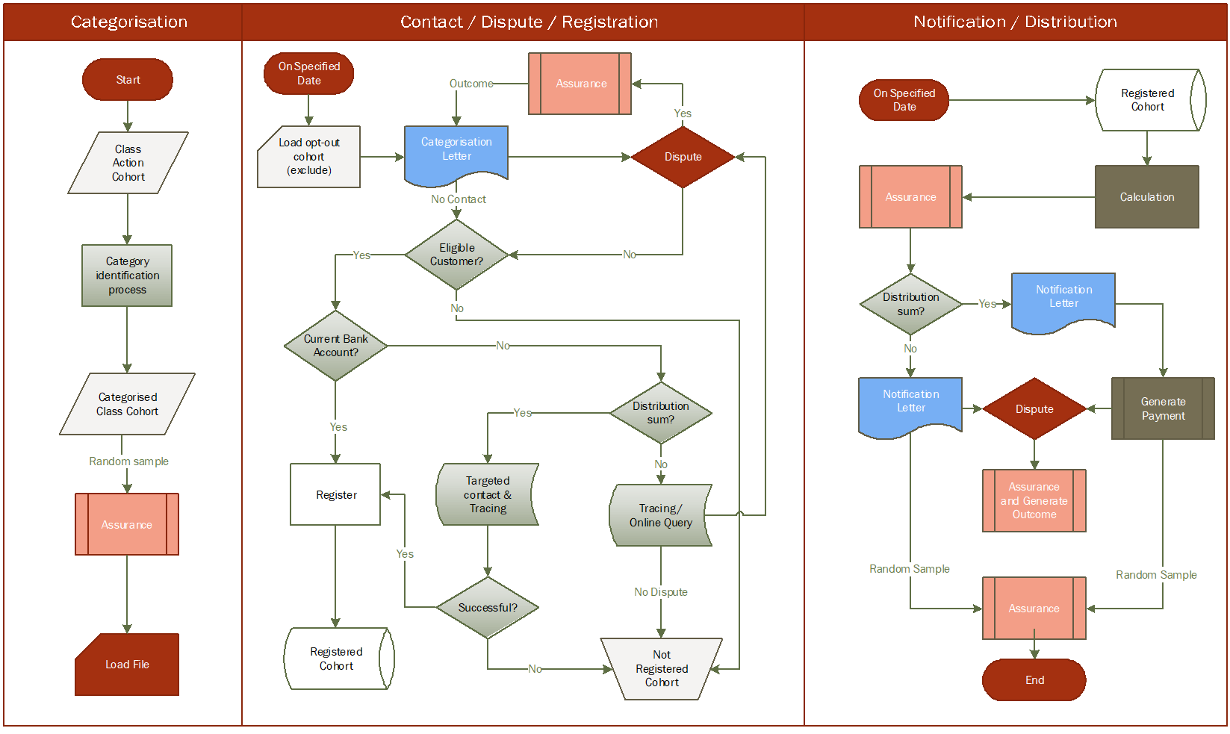

## ATTACHMENT B: CATEGORY DECISION TREE

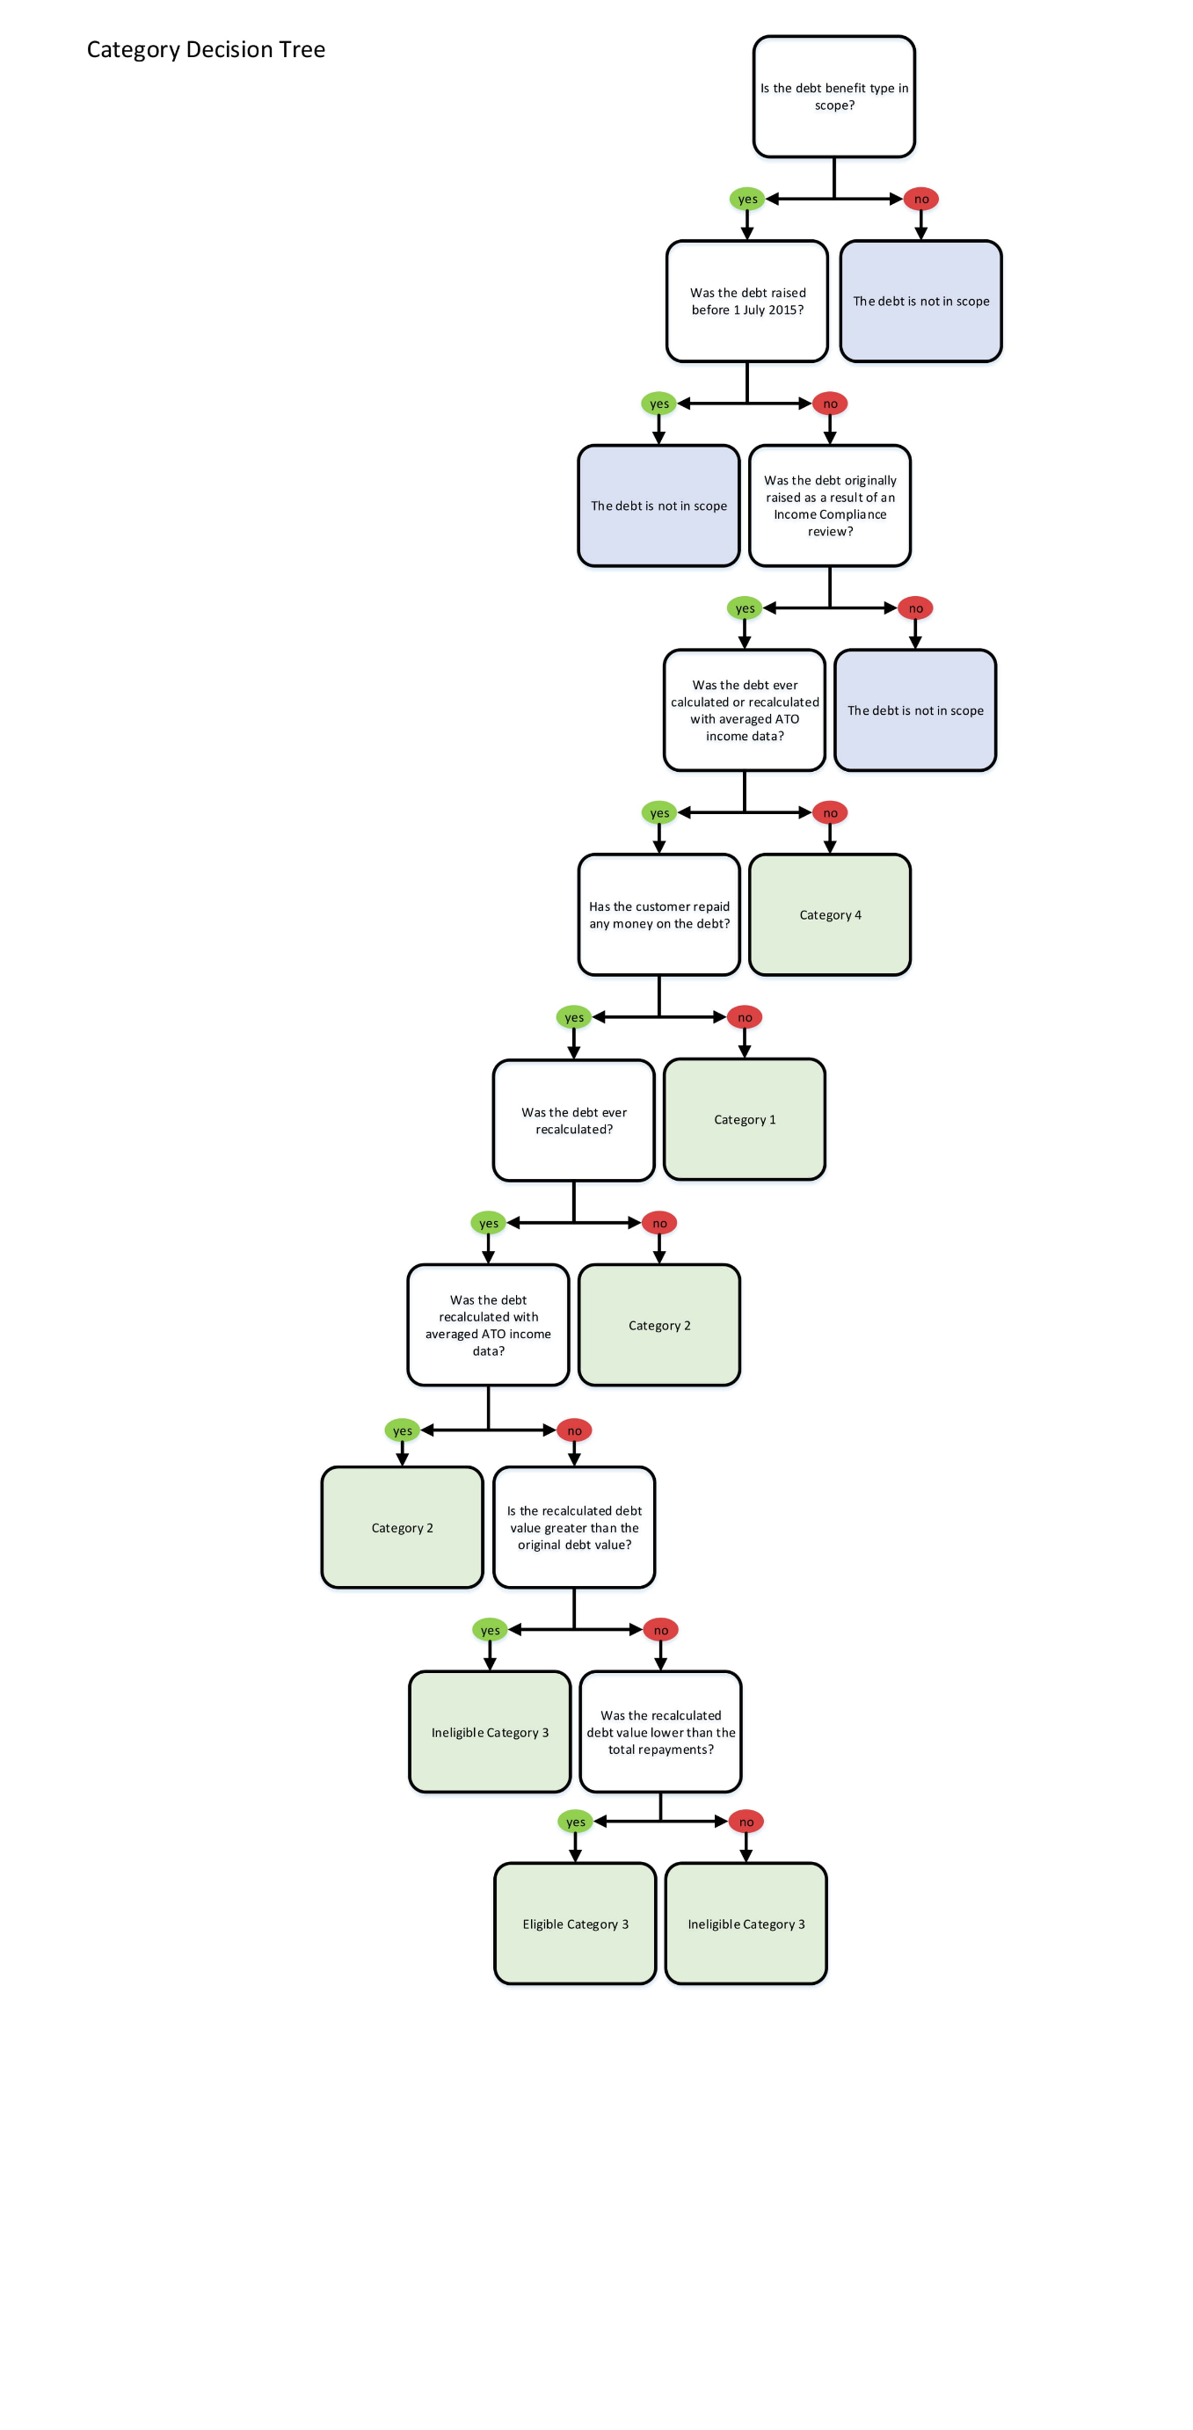

## ATTACHMENT C: RISK SUMMARY

The summary below outlines the high level risks to implementation of the agreed settlement of "Prygodicz & Ors vs the Commonwealth" (‘Robodebt’ (Social Security Debt Collection) class action), in accordance with this Implementation Plan.

| **Risk** | **Treatment** |
| --- | --- |
| The Court may direct that the distribution process be varied as part of approving the settlement. | The planned schedule includes sufficient unallocated time to allow for adjustment of the delivery approach to accommodate the Court’s orders.  If the settlement is not approved, the Settlement Distribution Scheme will not be required. If the Court varies the distribution process, the Implementation Plan will be amended to reflect the Court’s requirements. |
| Incorrect or misleading information on the Settlement Distribution Scheme is available in the public domain, or published through media or social media channels | Development of communication strategy with dedicated communication team support. |
| Class action Group Members do not understand the settlement distribution process, their eligibility or review rights. | Clear communications to be issued to the class action Group Members.  Dedicated webpage and phone line to be established for settlement enquiries, with consistent scripting and referral protocols provided across the broader agency for customers seeking information through general contact channels. |
| The categorisation process does not provide the correct outcome for some class action members. | The categorisation process shall be reviewed by the Scheme Assurer, including random sampling to verify accuracy. The Scheme Assurer’s report on categorisation shall be made available to Gordon Legal as the class action Group Members’ legal counsel.  A dispute resolution process shall be established to allow class members to seek review of their categorisation through the agency in the first instance, with a second tier of review by the Scheme Assurer available. |
| The calculation of settlement payments is not correct. | The calculation process shall be reviewed by the Scheme Assurer, including random sampling to verify accuracy.  Class action Group Members who are entitled to a settlement payment shall be advised in writing prior to payment being made. A dispute resolution process shall be established. |
| Staff resources initially allocated to the Settlement Distribution Scheme are not sufficient to meet demand. | The agency actively reallocates trained staff to respond to changes in demand. |
| Development of ICT to support implementation of the Settlement Distribution Scheme does not deliver a suitable product or takes longer than forecast. | The Scheme Assurer to review the ICT system design, build and release to support administration of the scheme.  The planned schedule allows additional time to be allocated to ICT development if required, within the overall time available to implement the Settlement Distribution Scheme. |
| Class action Group Members with special circumstances require additional support. | A tailored servicing approach will be implemented for customers with special circumstances, including manual processing and direct contact as appropriate. Additional support services such as social worker support shall be made available as needed. |