New look Medicare Card
Medicare is turning 40. To celebrate, the Medicare card will have a 2024 commemorative design.
If you get a new or replacement card from 1 February 2024, it’ll be a 40 year Anniversary card. This card design will be issued until 31 December 2024.
Medicare cards will also be updated in your Medicare online accounts, Medicare Express Plus mobile app and myGov app.
Find out more about the Medicare card at servicesaustralia.gov.au/medicarecard

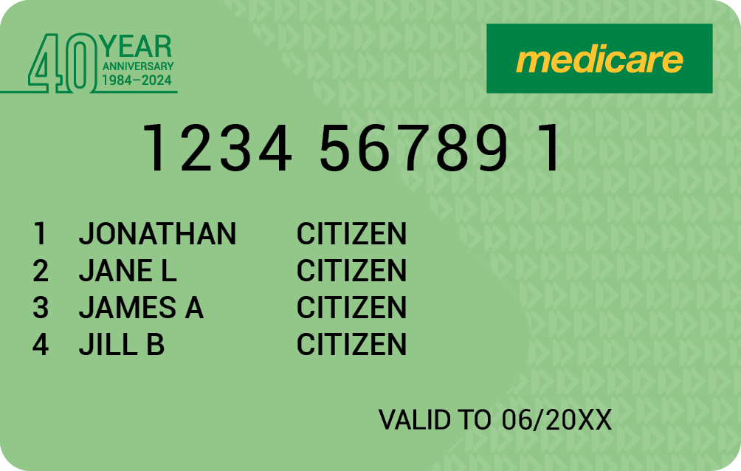
Commemorative card available from 1 February – 31 December 2024

