New look Medicare card
- To celebrate Medicare turning 40, the Medicare card will have a 2024 Commemorative design.
- If you need to get a new or replacement card from 1 February 2024, it’ll be a 40 year Anniversary card.
- This card will be issued until 31 December 2024.
- The old version will continue to be valid until the expiry date on the bottom right corner of the card.
- The Medicare cards will also be updated in your Medicare online account, Express Plus Medicare app and myGov app.
- For more information about Medicare cards go to servicesaustralia.gov.au/medicarecard

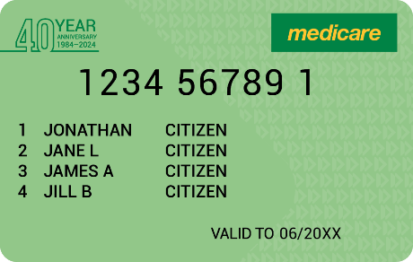
Commemorative card available from 1 February – 31 December 2024

