Farm Household Allowance case study
Financial support helps farmers after severe weather
Hung and My are tomato growers from the Adelaide region, supplying fresh produce to both local markets and across state lines.
‘We’re approaching almost 20 years of farming. It’s extremely hard work. Normally we work about 14 to 16 hours a day,’ Hung said.
During their time growing in this region, they’ve had 3 major hailstorms rip through their farm.
‘The last hailstorm that came through, basically damaged all the infrastructure that protects our tomatoes from the elements.
‘That meant we couldn’t grow anything for the whole year, due to exposure to the heat in summer and colder temperatures in winter. You need a very controlled environment to grow good quality products,’ Hung said.
After a visit from a Rural Financial Counsellor, Hung and My found out how Farm Household Allowance (FHA) could help them get back on their feet.
Living and working in a rural area made it difficult for them to visit a service centre. They applied online, which made processing their claim quicker, allowing them to get the support they needed sooner.
‘The support really helped us get by and allowed us to maintain our everyday standard of living. We received supplements as well, so we could study and expand our knowledge and skills,’ Hung said.
You can claim online, through your Centrelink online account linked to myGov. If you don't have an online account yet, you can create one by going to my.gov.au
You and your partner can also make a combined claim online, saving you time.
FHA also includes $10,000 in activity supplements, which you can use to pay for activities you do while you’re getting FHA. This can be used for things like professional advice, training or upskilling to increase your income. It can help with improving your farm operation, diversifying, developing off-farm skills or moving out of farming if you decide that's a better option.
For more information, call the farmer assistance hotline on 132 316 or visit our website.
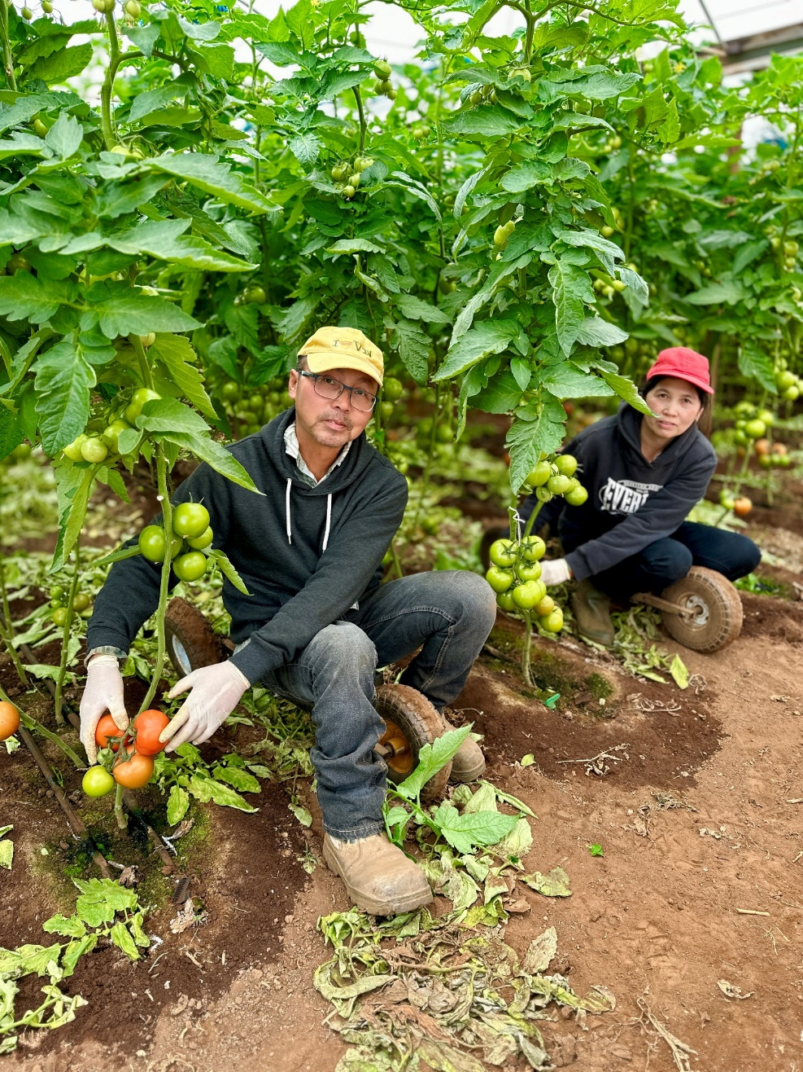
Pictured: Hung and My tending to their tomato plants

