Now is the time to claim ABSTUDY for your high school child

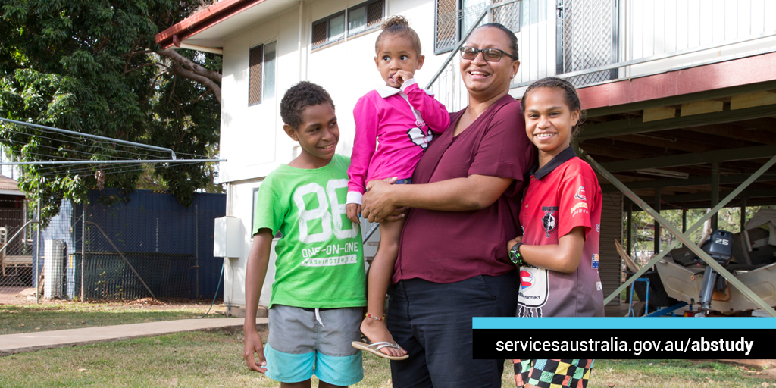

ABSTUDY is a group of payments for Aboriginal and Torres Strait Islander Australians. ABSTUDY helps with the costs of studying or doing an Australian Apprenticeship.
It can help with your child’s school fees, boarding costs, travel to and from school and other school items. If your child’s travel is impacted by COVID-19 or they need to study remotely, ABSTUDY can also help.
If you’re a parent or guardian and your child is younger than 16, you should claim on their behalf. If your child is 16 and over, or independent, they can claim themselves.To claim, call the Services Australia’s ABSTUDY line on Freecall 1800 132 317.
If they’re starting uni or TAFE, they’ll be able to claim online through myGov.
Claiming before 1 December means ABSTUDY payments can be finalised in time for the start of school next year. This is very important if your child needs to move away from home to study.
To see what you or your child can get, and learn how to claim, go to servicesaustralia.gov.au/abstudy

