**Program Protocol**

Matching third party income stream information with Services Australia

Automation of Income Stream Reviews (AISR)

**September 2025**

Table of Contents

1. Description of the Program Protocol 4

1.1. Purpose 4

1.2. Requirement for a Program Protocol 4

1.3. Definition of data-matching 4

2. Description of the program 5

2.1. Summary of the program 5

2.2. Objectives 5

3. Agencies involved 6

3.1 Source agencies 6

3.2 Matching agency 6

3.3 Primary user agency 6

4. Data issues 6

4.1. Data integrity and quality 6

4.2. Data security 8

5. The matching process 8

6. Action resulting from the program 9

7. Time limits applying to the program 10

8. Public notice of the program 10

9. Reasons for conducting the program 11

9.1. Relationship with our lawful functions 11

9.2. Social considerations 11

9.3. Voluntary compliance 12

9.4. Reduction in regulatory impacts 12

10. Legal authority 12

10.1. The agency 12

10.2. Income stream providers 13

11. Disclosure of information provisions 13

12. Alternative methods 13

13. Prior data-match programs 14

14. Costs and benefits 14

15. Evaluation of the program 15

Appendix A – Technical standards report 16

a) Description of data 16

b) Matching techniques 20

c) Risks 21

Appendix B – Services Australia – income stream request 23

Appendix C – AISR debt letter template 25

1. Description of the Program Protocol
   1. Purpose

The purpose of the program protocol is to:

* identify the matching agency and the source agency
* detail the direct relationship of the program to the performance of the lawful functions or activities of the matching agency
* set out the legal basis for any collection, use or disclosure of personal information involved in the program
* outline the objectives of the program, including:
  + the data-matching process
  + the nature and frequency of the matching in the program
  + the justifications for it.
* explain what methods, other than data-matching, were available to us and why they were rejected
* detail any cost/benefit analysis or other measures of effectiveness we considered in deciding to initiate the program
* outline the technical controls proposed to ensure data quality, integrity and security in the program
* outline the nature of the action proposed to be taken in relation to the results of the program
* outline any letters we use
* indicate what form of notice we will give, or intend to give, to individuals whose privacy is affected by the program
* specify any time limits on the conduct of the program.
  1. Requirement for a Program Protocol

Agencies conducting certain data-matching programs are required to prepare a Program Protocol. This requirement is in accordance with the Office of the Australian Information Commissioner’s (OAICs) *Guidelines on Data-Matching in Australian Government Administration* (Guidelines). These Guidelines are voluntary and represent the OAICs view of best practice.

Services Australia (the agency) complies with these Guidelines.

Our Privacy Policy:

* outlines how a person can complain about how we handled their personal information
* outlines how we deal with such a complaint
* is available at [servicesaustralia.gov.au/your-right-to-privacy](https://servicesaustralia.gov.au/your-right-to-privacy).
  1. Definition of data-matching

Data-matching is the comparison of two or more sets of data to identify similarities or discrepancies. We will use computer programs and techniques to compare data found in two or more files to identify cases where there is a risk of incorrect payment.

1. Description of the program
   1. Summary of the program

We deliver a range of programs for payments and services on behalf of the Commonwealth and in accordance with agreements with client agencies. To maintain the integrity of these payments and services, we undertake compliance activities to ensure:

* entitlement eligibility
* recovery of incorrectly paid benefits where required.

In the 2016-17 Mid-Year Economic and Fiscal Outlook (MYEFO), the Australian Government announced the Automation of Income Stream Reviews (AISR) measure.

The purpose of this measure is to streamline our processes for collecting information about changes to income stream products held by our customers.

The measure:

* reduces the regulatory and administrative burden on income stream providers
* reduces unnecessary customer contacts with the agency
* improves efficiency
* ensures both the accuracy of payments delivered and concession cards issued, under Australia's social security system.

Legislative changes came into effect on 29 March 2017 and 19 December 2017, allowing us to collect information about income stream products held by customers and their partners to ensure they are receiving their correct entitlement. We conduct reviews throughout the year to ensure we are using up to date information when assessing their ongoing rate of payment.

Data matching allows us to conduct the reviews for these products without contacting customers in the majority of cases.

We will issue a notice to income stream providers other than Self-Managed Superannuation Funds and Small Australian Prudential Regular Authority Superannuation Funds to supply information electronically about products held by their members. Some examples of income stream providers include:

* Australian supernation funds
* Retirement Savings Account providers
* Life insurance companies.

We will match the information to details on our records and use this to update the income stream products held by customers and their partners. We are required to delete any information not matched, or used, within 13 weeks of being received by us.

Income stream providers and their financial administrators, where applicable have been required to comply with the data matching process since 1 January 2019.

More information about [income stream product providers](https://www.servicesaustralia.gov.au/information-for-income-stream-product-providers) is available on our website.

* 1. Objectives

The objectives of this matching program are to:

* reduce the regulatory burden on customers and income stream providers in relation to income stream reviews
* ensure our customers continue to receive their correct entitlements
* detect and address non-compliance and fraudulent activity.

1. Agencies involved
   1. Source agencies

The source agencies that supply data for the purposes of this program are:

* income stream providers
* financial administrators on behalf of income stream providers (where applicable).
  1. Matching agency

The agency is the matching and user agency involved in this program.

* 1. Primary user agency

The agency makes the most substantial use of the program’s results. We receive the source data from income stream providers to ensure the accuracy of payments delivered and concession cards issued. We may supply management information reports to the Department of Social Services (DSS), derived from data matching outcomes, to ensure ongoing effectiveness of the program. We will remove personal identification information from reports provided to DSS.

1. Data issues
   1. Data integrity and quality

The provision of poor-quality data from income stream providers is of limited value in data-matching. As the matching agency, we verify the integrity of the data received from income stream providers. We perform quality assurance checks to ensure correct formatting and data is present in all mandatory fields.

We maintain a high level of data integrity. Measures we undertake to maintain integrity levels include:

* designing systems that will not accept incomplete records
* identifying and correcting records that have inadequate or corrupt data items.

The data schema we supply to income stream providers tells them the format required to allow us to ingest the data. If the data supplied does not meet the requirements in the schema, we generate an error report. We will advise the income stream provider of any data error and ask them to correct and resupply the data.

For example, for the DATE_OF_BIRTH field, the customer’s date of birth, the income stream provider must supply this as YYYYMMDD format.

For example, 1 March 1950 = 19500301.

We are unable to ingest the data and will generate an error report if the income stream provider data does not include the following:

* a value
* a value is not a determinable date.

Data quality mechanisms include:

* field level validation requirements applicable to any files and/or data received from the income stream providers, for example:
  + mandatory fields present
  + correct data type of values provided
  + “reasonableness” checks of the values provided.
* file level validation requirements applicable to any files received from the income stream providers. For example validation to ensure the file received:
  + is complete
  + in the correct format.
* record updates that fail validation business rules are referred for staff intervention and review. This applies to the following customer records where the update is not automatically completed with data received from the income stream providers:
  + partial identity or product matching decisions
  + account balance changes and commutation amounts that fall outside the set dollar thresholds
  + discrepancies in information reported compared to what we hold on the customer’s record
  + updates resulting in payment suspensions or cancellations
  + updates resulting in debts or significant variations to a customer’s weekly entitlement.

We have extensive experience undertaking complex data matching programs. This includes applying well established matching criteria to limit instances of incorrectly matched data.

We maintain processes for managing data integrity, incorrectly matched data and mitigating any potential privacy impacts. For example:

* the Income Stream Providers User Guide outlines steps for notifying us of an error in reported information
* staff resources contain steps for staff to escalate a reported or identified data matching issue
* under our Privacy Incident and Data Breach Response Plan, the agency will notify affected individuals and the OAIC when a data breach is likely to result in serious harm. This plan supports the agency’s compliance with the Eligible Data Breaches Scheme and Australian Privacy Principles (APPs) in the *Privacy Act 1988*. More information is available at: [How Services Australia protects your personal information after a data breach - Managing your money - Services Australia](https://www.servicesaustralia.gov.au/how-services-australia-protects-your-personal-information-after-data-breach?context=60271).

As part of ongoing measures to improve data quality, we introduced an amendment data schema which providers could opt-in to using. If the provider submits erroneous data, they can lodge a corrected file to amend or remove previously submitted data. For example, an income stream provider submitting a gross annual income amount of $100,000 instead of $10,000.

If an income stream provider informs us, or if we identify that we hold inaccurate information, we will take steps to amend the information. We may request evidence from an individual or third party as part of this process. It is the individual’s responsibility to provide accurate information to us. We have provided instructions on how to access and correct personal information in the [Privacy Notice for Automated Income Stream Reviews](https://www.humanservices.gov.au/individuals/enablers/schedule-2-privacy-notice-income-stream-reviews) published on our website.

* 1. Data security

We use file-based exchange solutions by Sterling eCommerce MFT for bulk file exchanges.

This solution provides the ability for income stream providers to communicate and provide information securely to us.

We hold data received in secure data platforms. These are core systems that employ strict security controls. Only our employees with a business need have access to view the data received, as described in this protocol.

Our staff are also subject to the statutory secrecy and confidentiality provisions under the:

* *Social Security (Administration) Act 1999*
* *Public Service Act 1999*
* *Criminal Code Act 1995*

We are also subject to the *Privacy Act 1988*. We strictly control access and entry to our computer centres.

Our security system provides protection and control of dataset access, system entry and program integrity. Our security features include log on identification codes, passwords and security groupings to ensure access to information is on a needs only basis. We monitor and log all access to our systems.

Our existing security arrangements automatically log user access to data files.

1. The matching process

We will conduct identity matching to match income stream providers’ data to the identity of our customer or their partner.

The identity matching process will use various elements and/or combinations of the following data fields:

* Sex
* Surname
* First Name
* Other Given Name
* Date of Birth
* Address
* Locality
* Post Code
* State Code
* Product Reference Number.

We will use three sets of data elements, depending on the income stream product, to collect information from income stream providers about their customers with:

* account-based and market-linked income streams
* defined benefit income streams and military invalidity pensions
* lifetime, life expectancy, and term income streams.

There will be some overlap between the three datasets.

Each income stream provider will supply information in respect of all their members so we can identify and update mutual customer records. In other words, we will collect information about:

* our customers and their partners who hold a particular type of income stream product
* recipients of income stream payments who do not receive a relevant social security payment.

Following a data matching process, we will delete all non-customer data within 13 weeks of receipt of the data file. This is in accordance with subsection 195(5) of the *Social Security (Administration) Act 1999*.

The matching process will only match and automatically apply information when it determines a match with a suitably high confidence level. Our staff will manually review matches that the matching process identifies with a lower confidence level before we apply the match. This is to uphold an individual’s right to privacy.

We removed Sex as a field for identity matching from 3 December 2022, though it still forms part of the data sets for providers.

You can find a technical standards report at Appendix A.

1. Action resulting from the program

We use matched record information to review and update income stream information held on our systems. We use this information to correctly calculate social security payments and concession card entitlements.

Depending on the result of the matching, the following range of administrative actions may occur:

* an existing income stream product is updated on a customer or partner’s agency record resulting in:
  + no change to existing entitlements
  + increase to existing entitlements
  + decrease in existing entitlements
  + cancellation of existing entitlements.
* arrears payment issued to a customer due to an underpayment
* debt raised for a customer due to an overpayment
* identification and update of a non-disclosed income stream product
* no changes to the customer or partner record.

If we require more information before making a determination based on the provider data, we will issue a request for information to the customer.

Refer Appendix B – Services Australia – income stream request.

We will issue a notice in writing to customers to recover an amount paid when the customer has not:

* provided correct information
* provided updated information in a timely manner
* disclosed an income stream to us.

We will include in the notice, information on the customer’s rights to request an internal review of this decision.

There is no time limit applicable to a customer’s right to internal review. If the customer is not satisfied with an internal review outcome, they can then seek independent review by applying to the Administrative Review Tribunal (ART).

Refer Appendix C – AISR debt letter template.

1. Time limits applying to the program

We delete data matching information that has not been used within 13 weeks of being received by us. We also destroy any unmatched data within 13 weeks of receiving it from the income stream provider.

We do not keep a permanent record of people who are matched or not matched in this program. We destroy all data from income stream providers where we decide not to take action. This is in accordance with s195(5) of the *Social Security (Administration) ACT 1999* and is in line with Guideline 7 of the OAIC Guidelines.

We retain data that we match to a customer’s record according to an archive schedule. The data remains available should we or the customer want to review a decision.

1. Public notice of the program

The Australian Government announced the program to the public as part of the 2016-17 Mid-Year Economic and Fiscal Outlook announcements. Information about the changes is publicly available on the [Budget 2016-17](https://archive.budget.gov.au/2016-17/myefo/2016-17-MYEFO-combined.pdf) and DSS website.

We will let people know about the data-matching program through the following channels:

* our website
  + News items or relevant communication, alerting our customers of the automation changes, including the introduction of data matching
  + updates to existing income stream review information for customers and third-party providers
  + access to a [data matching program protocol](https://www.servicesaustralia.gov.au/centrelink-data-matching-activities?context=22)
  + access to a [Privacy Notice specific to Automated Income Stream Reviews](https://www.servicesaustralia.gov.au/privacy-notice-for-automated-income-stream-reviews).
* collaboration with income stream providers, administrators and peak industry bodies
  + regular consultation with income stream providers during transition to the automated process
  + appropriate notice and messaging to fund members about the data matching
  + provision of the links to our data matching protocol and privacy notice to income stream providers
  + encouraging providers to publish links to the data matching protocol and privacy notice on their fund’s website
  + articles in external publications initiated by peak financial industry bodies, including superannuation providers, financial planners, accountants and banking representatives
* our staff communication channels for messaging to customers through
  + our Financial Information Service Officer (FISO) Network
  + face-to-face and telephony staff.

We expect the data matching program to include approximately half a million customers, although this figure will vary depending on:

* volume of customers currently receiving an income support payment or concession card
* whether income stream providers lodge files by the due dates for the relevant review period
* the quality of data supplied by income stream providers.

Our website provides additional [Information for income stream product providers](https://www.servicesaustralia.gov.au/information-for-income-stream-product-providers).

1. Reasons for conducting the program
   1. Relationship with our lawful functions

The program assists our lawful function of paying customers accurately under:

* the *Social Security Act 1991*
* the *Social Security (Administration) Act 1999.*

These requirements are provided to customers in writing.

Section 195 of the *Social Security (Administration) Act 1999* enables us to obtain the agreed data set from source organisations. We must provide written notice under section 196 of the *Social Security (Administration) Act 1999* to the income stream provider.

* 1. Social considerations

Welfare is often topical and of interest to the media and the general public. There are some key social issues associated with the program:

* that only persons entitled to receive payments from us do so and they receive correct entitlements
* the desire of taxpayers for the income support system to ensure integrity in its payments, services and recovery processes
* an individual’s right to privacy.

There is strong support in the community for an income support system that only pays those who are eligible. The program helps to achieve this in two ways:

* strengthening controls in our payment and recovery systems. This reduces government outlays from our programs and allows Government funding for other priorities
* the existence of effective controls in payment and recovery systems, increases voluntary compliance

We include suitable safeguards against unreasonable intrusion into the privacy of individuals in the data-matching arrangements. Matching is conducted in accordance with the OAIC Guidelines.

* 1. Voluntary compliance

Community compliance with social security law increases when it is known we have systems to detect incorrect payments and fraud. That is, people claiming or receiving income support payments are more likely to voluntarily comply if they know the following:

* there is a high probability that we will detect incorrect payments
* customers will need to repay any debt
* customers may be penalised for attempting to obtain payments by fraud or misrepresentation.

The extent of the voluntary compliance from this initiative is difficult to measure. We have not attempted to estimate the monetary benefits.

* 1. Reduction in regulatory impacts

The program reduces ongoing administrative costs for providers and customers by simplifying how income stream information is sent to us. This is because:

* we send significantly fewer requests to providers and administrators to issue Centrelink Income Stream Schedules to customers
* customers no longer need to provide information about their or their partner’s income streams for our income stream reviews.

The program also meets customer preferences to have this information collected directly from providers.

1. Legal authority
   1. The agency

* Section 195(2) (ja*)* of the *Social Security (Administration) Act 1999* allows us to obtain an agreed dataset from income stream providers, with effect from 13 April 2017.
* The dataset was further detailed by legislative instrument issued under Section 195(3A) of the *Social Security (Administration) Act 1999* with effect from 19 December 2017.
* All income stream providers or administrators are requested by us to provide the dataset of all their members.
* We issue this request under section 196 of the *Social Security (Administration) Act 1999*.
* Our disclosure to, and collection of, information from income stream providers is specifically allowed under:
  + paragraph 202(2)(d) of the *Social Security (Administration) Act 1999*
  + Australian Privacy Principles 3.1 and 6.2(b) in Schedule 1 of the *Privacy Act 1988* (cth)
* This is because it is reasonably necessary for the proper administration of payments and services under the social security law.
* Paragraph 202(2)(d) of the *Social Security (Administration) Act 1999* also authorises our involvement in the data matching for the purposes of social security law.
  1. Income stream providers

In accordance with section 197 of the *Social Security (Administration) Act 1999*, income stream providers must comply with formal notices we issue under section 196.

1. Disclosure of information provisions

Income stream providers (and their financial administrators) only share required information with us. This information is used to determine if there is a difference between the information disclosed to us by the customer compared to the income stream providers. We will then decide if administrative action is required and only where appropriate, will we send a referral to the Commonwealth Director of Public Prosecutions.

We expect that third party providers who share information with us will have privacy collection notices and privacy policies in place. These will notify their members that the provider may share their information with a government body. Similarly, we will publish this protocol on our website. See section 8 above.

1. Alternative methods

The alternative methods to obtain income stream information are:

* introduce a full customer-based letter review process
* maintain the previous voluntary two-step data exchange process with some income stream providers and administrators.

Introducing a customer-based letter review process would increase the burden on individuals and third-party organisations. It would require individual customers to seek the information from income stream providers to supply to us. This would reduce efficiencies gained under the current partially automated process.

Our previous voluntary data exchange process was cumbersome. It was a two-step process requiring additional effort by the provider and us.

* Section 195 of the *Social Security (Administration) Act 1999* authorises the collection of information about a class of persons by the Agency
* Participating income stream providers or administrators are requested by us to provide a data file of identity details of all their members
* We issue this request under section 196 of the *Social Security (Administration) Act 1999*
* We use the supplied data to identify our customers and their partners
* We delete any information we don’t match with our customers or use within 13 weeks of our receipt of the file
* Throughout the year we compile and send a data file of the identified customers and their partners to the income stream provider or administrator
* We request information for the income streams held only by these customers and their partners
* The Agency has the general power to obtain information about a customer under section 192 of the *Social Security (Administration) Act 1999*
* The providers or administrators provide the information to us, and we update the products held by customers and their partners.

A two-step data matching process does not give us the ability to collect all income stream information from the source without multiple intervention points. Legislative changes have allowed us to collect information in a single step process to update income stream products more efficiently. It also introduces capability to identify non-disclosed income streams to improve payment accuracy.

1. Prior data-match programs

We have been working together with a number of income stream providers since 2006 to conduct data matching. The previous voluntary data matching used a two-step data transfer process due to restrictions under section 195 of the *Social Security (Administration) Act 1999*.

The main difference between the prior data match programs and the new program is:

* the AISR measure mandates that providers supply all income stream information electronically to us
* we use an improved data matching routine that we are using for other data matching programs
* it is also streamlining the previous two-step data exchange process into a one-step process following legislative amendments
* the AISR measure allows us to identify non-disclosed income stream products more efficiently.

1. Costs and benefits

The implementation of the measure cost approximately $8.3 million across the forward estimates to 2019-20. The cost reflects the expense of designing and building the required IT infrastructure to support the automated process. The Federal Government recovered costs within the first 5 years with an ongoing benefit thereafter through reduced manual reviews, debt processing and print and postage expenses.

AISR will improve the accuracy and efficiency of Australia’s social security system by:

* increasing payment accuracy for customers or their partners who hold an income stream product
* reducing ongoing administrative and regulatory costs for providers and customers
* allowing us to identify and address income stream notification non-compliance. This will lead to greater increases in voluntary compliance and reduce debt
* allowing us to complete income stream reviews without the need for customer intervention in most cases.

We monitored and tracked the program’s benefits against the pre-implementation baselines over four years. Benefits realisation relies on the data matching program increasing accuracy and efficiency through an automated review process. Alternative methods would not achieve the same benefits.

The volume of customer contacts has reduced since implementing these reviews because:

* customers no longer need to travel to the service centre to complete the review
* by the agency regularly reviewing all account-based, market-linked and defined benefit income stream products, this results in less inbound calls from customers
* automatic updates of information reduce impost on professional resources, for example accountants, financial planners, and income stream providers.

The integrity of data on our system has improved, resulting in automated updates and improved payment accuracy.

1. Evaluation of the program

We will evaluate the program at least every three years while the program continues. We will provide our documented findings in an evaluation report to OAIC and make it publicly available. We will update our Privacy Policy and relevant collection notices to reflect changes to the management of personal information for this program.

Appendix A – Technical standards report

1. Description of data

Identity and income stream data file is sent from income stream providers to us:

* Source organisations will transfer the following data items to us.
* We will conduct the identity matching process and review and update the income stream information held by matched persons only
* Specific data sets will collect the required income stream information for the varying income stream product types.

Outlined below are descriptions of the data contained in the three data sets.

Table 1 - Account-based and Market Linked Income (MLI) Stream Reviews

Reviews conducted biannually in August and February

| **Field name** | **Meaning** |
| --- | --- |
| First name | Client’s first name |
| Second Name/Initial | Client’s second name or initial |
| Surname | Client’s surname |
| Date of Birth | Client’s date of birth |
| Sex | Sex of person |
| Address Line 1 | Street number and name |
| Address Line 2 |  |
| Suburb/Town | Address suburb or town |
| State | Common state identifier |
| Postcode |  |
| Overseas country |  |
| Business Partner ID | Unique identifier issued to providers by us upon registration for the data transfer process |
| Provider ABN | This ABN should be the same as reported on the schedule for the provider name reported. |
| Product Type Code | Product type either Account-based income stream (**AIS**) or Market Linked Income (**MLI**) for Market- linked income stream) |
| Product reference number | Unique identifier for the client’s income stream.  Must be exactly the same as reported on the schedule. |
| Did the owner become a reversionary beneficiary in the last 6 months? | Income stream will automatically revert to this person following the death of the primary pension beneficiary. |
| Date reverted to reversionary beneficiary | This is the day after the date of death of the primary pension beneficiary. |
| Complies with section 9BA | If the product is a MLI does it comply with Section 9BA of the *Social Security Act 1991*? Answer should be ‘NO’ if purchase date is on or after  20 September 2007 and does not meet the conditions for retention of asset-test exemption. |
| Purchase date | This is generally the date the client signs the contract and is the same as the commencement date. It is not the date of the first payment made by the income stream provider to the client. |
| Relevant Number (**RN**) | **Account-based income stream:**   * If there is no reversionary pension beneficiary, the Relevant Number (**RN**) is the life expectancy factor of the primary beneficiary. * If there is a reversionary pension, the RN is the longer life expectancy factor of either the primary or reversionary.   **Market-linked income stream:**   * RN must be a whole number. * Refer to section 9BA of the *Social Security Act 1991* for calculation of RN for MLI. |
| Original purchase price | Includes fees but after deducted tax. Value in dollars and cents. |
| Gross annual payment | This amount must never be less than the minimum payment for a full financial year. Will comprise of all payments already received, excluding commutations, and expected payments for the remaining period. Cannot be zero if the product is current. Value in dollars and cents. |
| 1 July account balance | This is the balance used to calculate the minimum payment. Value in dollars and cents. |
| Current account balance | The latest available balance at time of data extraction. Note: account balance cannot be zero if the product is current.  Value in dollars and cents. |
| Date of current account balance | The date of the latest available balance at time of data extraction. |
| Total value of commutations since commencement | The total value of commutations including lump sum withdrawal in cash as well as a rollover.  Value in dollars and cents. |
| Total number of Commutations made within the last 6 months | **August Review Cycle –** The total number of commutations made in period 1 January – 30 June.  **February Review Cycle** – The total number of commutations made in period 1 July – 31 December.  This will allow for income stream providers to report the appropriate number of individual commutations below. |
| Commutation amount for each commutation in the last 6 months | **August Review Cycle** – Commutations made in period 1 January – 30 June.  **February Review Cycle** – Commutations made in period 1 July – 31 December.  Provide a commutation amount for each corresponding date below.  Commutation includes lump sum withdrawal in cash as well as a rollover. Value in dollars and cents. |
| Commutation date/s | Date of commutation corresponding to each commutation amount collected above.  If there are multiple commutations in the relevant period, multiple records need to be generated, i.e.   * August Review Cycle – Commutations made in period 1 January – 30 June of the current year * February Review Cycle – Commutation made in period 1 July – 31 December of the previous year |
| Commutation reason | The reason for the commutation. For market linked income streams only. The income stream provider is required to report within the reporting cycle of the commutation. |
| Expiry date | For MLI only, required in the final year of the product term. The *Superannuation Industry (Supervision) Regulations 1994* allow for some flexibility in the product expiry date. In the final year, expiry can be at the end of the actual term of the product or 30 June. |

Table 2 - Defined Benefit and Military Invalidity Pension Indexation Reviews

Reviews conducted depending on indexation dates (annual or bi-annual)

| **Field name** | **Meaning** |
| --- | --- |
| First name | Client’s first name |
| Second Name/Initial | Client’s second name or initial |
| Surname | Client’s surname |
| Date of Birth | Client’s date of birth |
| Sex | Sex of person |
| Address Line 1 | Street number and name |
| Address Line 2 |  |
| Suburb/Town | Address suburb or town |
| State | Common state identifier |
| Postcode |  |
| Overseas country |  |
| Business Partner ID | Unique identifier issued to providers by us upon registration for the data transfer process |
| Provider Australian Business Number (**ABN**) | The Australian Business Number (**ABN**) should be the same as reported on the schedule for the provider name reported. |
| Product Type Code | Product type: DEF (defined benefit) or MYP (military invalidity pension)  Only one Product type code can be in the file.. |
| Product reference number | Unique identifier for the client’s income stream.  Must be exactly the same as reported on the schedule. |
| Did the owner become a reversionary beneficiary in the last 12 months? | Income stream will automatically revert to this person following the death of the primary pension beneficiary. Income stream provider to report only if on an annual indexation review cycle. |
| Did the owner become a reversionary beneficiary in the last 6 months? | Income stream will automatically revert to this person following the death of the primary pension beneficiary. Income stream provider to report only if on a bi-annual indexation review cycle. |
| Date reverted to reversionary beneficiary | This is the day after the date of death of the primary pension beneficiary. |
| Payment suspended | If income stream provider has suspended member’s payment due to no contact. The suspension is temporary and the provider will restore when member establishes contact. |
| Date of payment suspension | The date the income stream provider suspended the member’s payment. |
| Commencement date | The date the pension commenced.  If reversionary, this will be the original superannuant’s commencement date. |
| Gross fortnightly payment | This is the amount paid fortnightly before deductions.  Must include payment in respect of children in the gross amount.  Value in dollars and cents. |
| Gross fortnightly payment in respect of children | If applicable as above.  Value in dollars and cents. |
| Number of children | If payment to children reported above. |
| Tax Free Component (**TFC**) method | This is the method used to calculate the Tax Free Component (**TFC**).  OLD = Pre 1 July 2007 rule based on Undeducted Purchase Price.  NEW: 1 July 2007 rule using the proportional method. |
| TFC amount per fortnight | If NEW, calculate TFC using the proportional method including the TFC calculated to determine the Special Reduction Amount for military invalidity pensions for Social Security purposes.  If OLD, calculate TFC using the method based on Undeducted Purchase Price (**UPP**) for income streams commenced before 1 July 2007.  Value in dollars and cents. |
| CPI date | Effective date of increase |

Table 3 - Lifetime, Life Expectancy and Term Income Stream Reviews

Reviews conducted annually in April

| **Field name** | **Meaning** |
| --- | --- |
| First name | Client’s first name |
| Second Name/Initial | Client’s second name or initial |
| Surname | Client’s surname |
| Date of Birth | Client’s date of birth |
| Sex | Sex of person |
| Address Line 1 | Street number and name |
| Address Line 2 |  |
| Suburb/Town | Address suburb or town |
| State | Common state identifier |
| Postcode |  |
| Overseas country |  |
| Business Partner ID | Unique identifier issued to providers by us upon registration for the data transfer process. |
| Provider ABN | This ABN should be the same as reported on the schedule for the provider name reported. |
| Product Type Code | Product type (either Lifetime income streams (**LIS**) or Life Expectancy income stream (**LIE**) or Term income stream (**TIS**). |
| Product reference number | Unique identifier for the client’s income stream.  Must be exactly the same as reported on the schedule. |
| Did the owner become a reversionary beneficiary in the last 12 months? | Income stream will automatically revert to this person following the death of the primary pension beneficiary. |
| Date reverted to reversionary beneficiary | This is the day after the date of death of the primary pension beneficiary. |
| Complies with section 9A/9B | Does the lifetime or life expectancy income stream comply with Section 9A/9B of the *Social Security Act 1991*? Should be ‘NO’ if:   * purchase date on or after 20 September 2007 and the product is not meeting retention of asset-test exemption conditions, or * a term income stream. |
| Jointly owned | Is there a joint owner? |
| Jointly owned percentage | What is the percentage owned? |
| Purchase date | This is generally the date the client signs the contract and is the same as the commencement date. It is not the date on which the first payment is made by the income stream provider to the client. |
| Relevant number | **Lifetime Income Streams:** Refer to Subsection 9(1) of *Social Security Act 1991*.  **Life Expectancy Income Streams:** Refer to subsection 9B(2) of *Social Security Act 1991*. If purchased on or after 20/09/04 the RN must be whole number.  **Term Income Streams:** The RN will be the actual term of the income stream. |
| Original purchase price | The original price paid for the income stream, including fees but after deducted tax. Value in dollars and cents. |
| Gross income | Gross amount paid before deductions.  Value in dollars and cents. |
| Payment frequency per year | Frequency of gross payment per year. |
| Indexation | Is the income stream indexed? |
| Type of indexation | CPI or fixed indexation |
| Indexation rate | If fixed |
| Indexation date | Next indexation date |
| Residual capital value | Amount of returned capital at the end of the term.  Value in dollars and cents. |
| Commutations made | Were any commutations made? Includes lump sum withdrawal in cash as well as a rollover. |

1. Matching techniques

Identity matching

We conduct identity data-matching with income stream providers (or their financial administrator, where applicable) to identify mutual customers.

We match customers to reported provider identity data with known customers within our data lake to identify mutual customers.

This could be:

* customer and partner
* partner, but not customer
* customer, but not partner.

How we match the data depends on the information provided. We have to use different business rules to obtain an accurate and valid match.

Our staff manually review low confidence matches to determine if the match is to be rejected or accepted as an identity match.

We load the providers’ income stream data, for matched customers or partners into our core systems, for income stream product matching.

**Income stream product matching**

We extract current information from our core systems, including the customer and partner’s:

* payment type
* payment status
* recorded income stream information.

We apply business rules to match provider data to recorded income streams to identify:

* products for automatic updating with the reported provider data
* discrepancies with recorded data for manual review by our staff
* non-disclosed products for compliance action.

We attach the provider’s income stream data to matched customers or partners for automatic updates and identified discrepancies.

We load the provider’s income stream data for matched customers or partners with non-disclosed products into our compliance systems for compliance action.

Our experience in matching the same data with the same matching criteria shows an extremely low number of instances of incorrect matching. We forward suspected mismatches to a specialist area who will do the following:

* check the matched identity
* check the match data for accuracy
* if required, consult the income stream provider or their financial administrator, where applicable regarding the data provided.

If we find a suspected mismatch is a correct match, we use the additional information to assess the case appropriately. However, if we discover it is in fact a mismatch, we remove incorrect data from the customer record and finalise the case.

1. Risks

**Incorrect identity matches**

We use sophisticated identity matching techniques to ensure they identify the correct recipients. The techniques use multiple details to obtain an identity match including a unique identifier defined by the income stream provider. For example, the name, address and date of birth are all items available and used in the identity matching process.

Very high confidence matches will only occur where all fields match to a person in both the provider’s data and our systems. We may undertake additional manual processes where high confidence identity matches occur, but not all fields match. We are constantly evolving and refining data matching rules and techniques to mitigate risks. We achieve this by utilising the learnings of past and present data matching exercises.

Incorrect identity matches could result in the breach of privacy of individuals, or incorrect changes to records. This could also result in incorrect debts or incorrect rates of payment that require remedial administrative action. Multiple instances create potential risk to our reputation.

Staff can nominate identified mismatches via a simple process for review and removal of data by our Information and Communications Technology (ICT) staff. These are also referred to the internal Data Quality Unit for further action to address any intertwined records. ICT also regularly report on possible mismatches where the data may have applied a match on multiple or alternative records.

Data quality controls and audit

Data provided by the income stream provider is subject to quality validation prior to ingesting and identity matching. The data matching process applies an automatic update only when the data matches a pre-existing product on a customer’s record. The data matching process refers provider data for manual processing by staff when the following occurs:

* the product is not matched to an existing product
* discrepancies are identified.

Identity matching is usually completed in our data lake within 24 hours of receipt. This depends on file size and number of files received that day. Data lake then sends matched data for processing and automatic updating on the customer’s record.

The data matching process checks to ensure the correct customer records are identified, before it refers any cases for possible compliance review. We will provide our customers with the opportunity to verify ownership of the income stream prior to any application of data.

Security and confidentiality

We strictly control our core systems with features including:

* system access controls and security groupings
* encrypting data and storing it in an immutable format
* log in identification codes and password protection
* full audit trails of data files and system accesses.

We only allow authorised users with appropriate security clearance to view the data supplied by income stream providers within our data lake. We have established a specific data tenancy for the data used in these reviews. Users must request this access and provide a suitable business case to ensure that access is appropriate.

The program owner must approve any changes to the system and how it operates before the relevant ICT team implements changes. Changes to the system and the management of data cannot occur without the program owner’s approval.

We record any access to the data tenancy. This is to ensure access is relevant to the data matching program or administrative action.

Disposal of information supplied for the data matching program occurs in alignment with relevant legislative and policy requirements. See Section 7.

Appendix B – Services Australia – income stream request

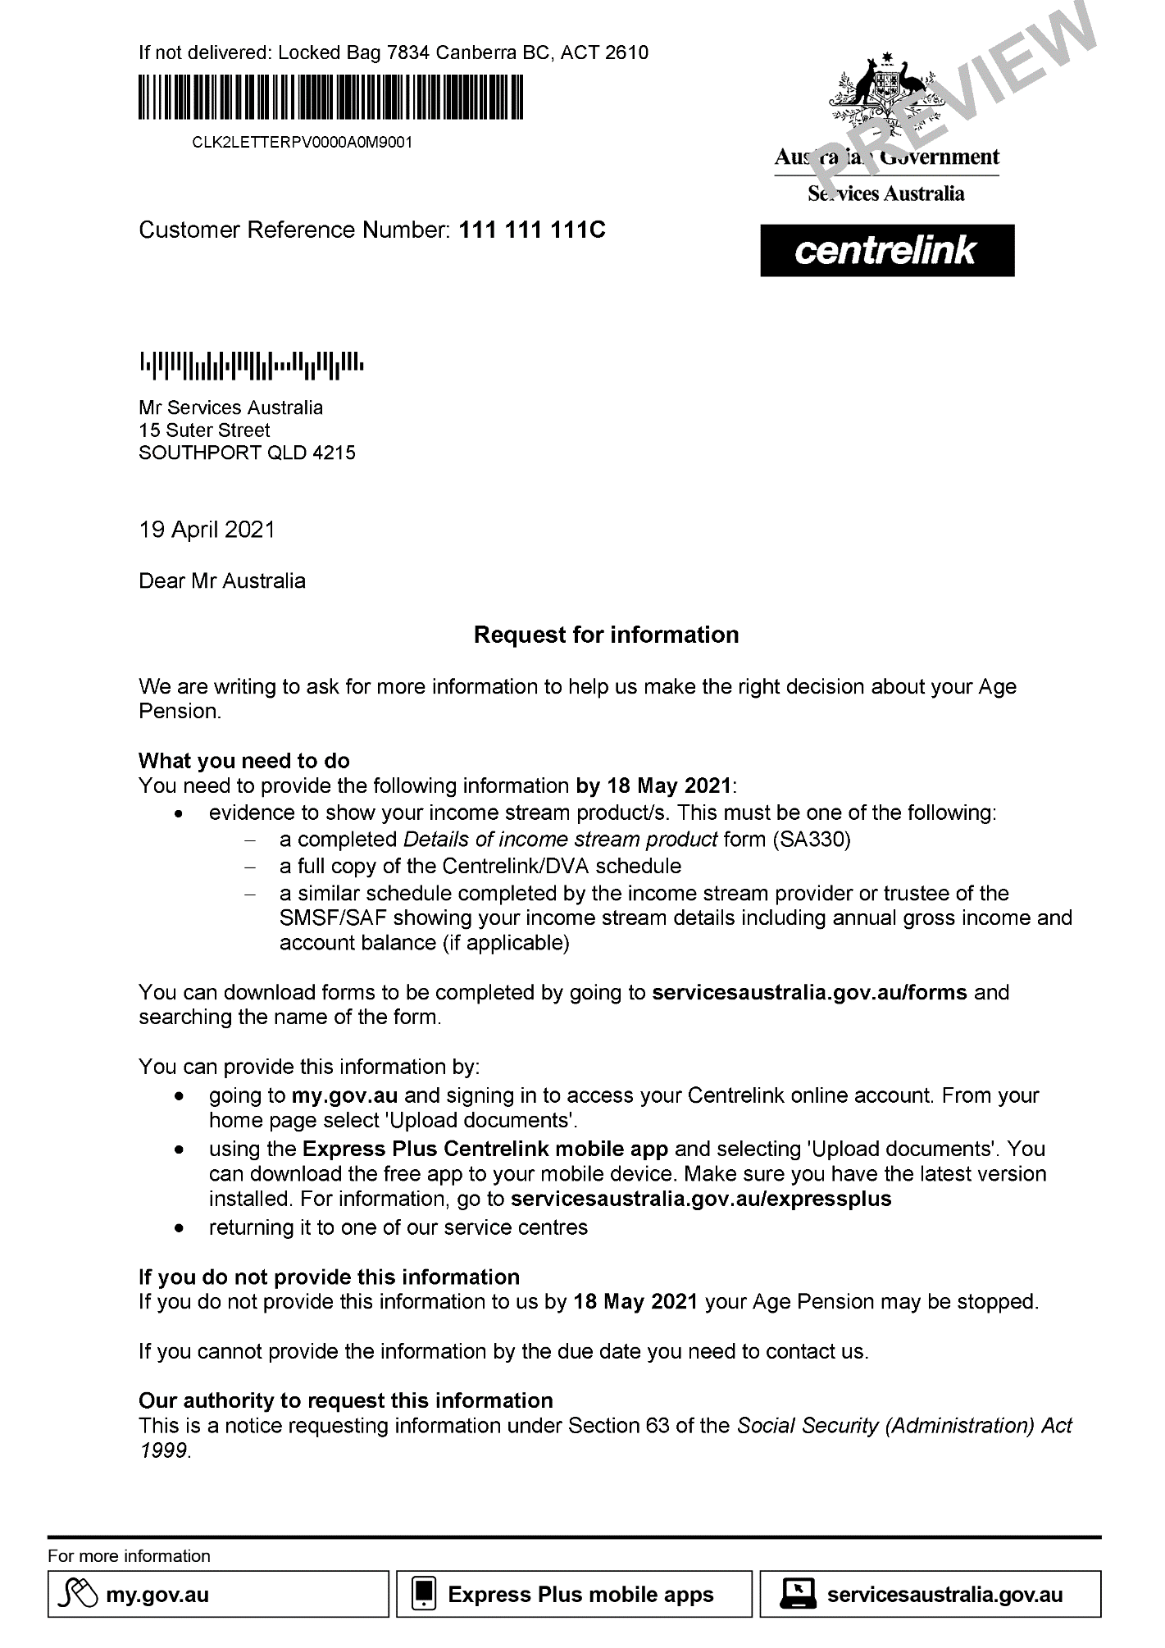

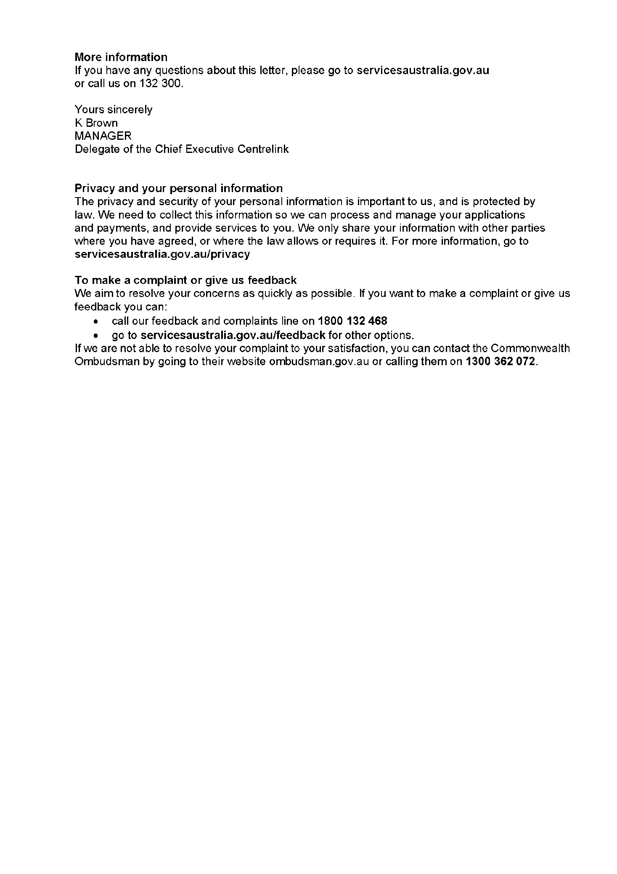

Appendix C – AISR debt letter template

