ABSTUDY travel

authorisation booking form

user guide

RESOURCE FOR SECONDARY BOARDING PROVIDERS

Contents

About the ABSTUDY travel authorisation booking form 3

How to complete the booking information sheet 4

CTM booking information 4

Institution contact information 5

ABSTUDY travel team contact information 5

Privacy notice 5

How to complete the travel arrangements sheet 6

How to complete the linked travellers sheet 9

This guide helps you use the ABSTUDY travel authorisation booking form to request, amend or cancel ABSTUDY travel arrangements.

It’s important you complete all relevant sections of the form to make sure:

* travel requests are actioned in a timely manner
* correct traveller details are sent to the travel management company
* travel disruptions can be managed effectively.

The screenshots in this guide are examples only.

# About the ABSTUDY travel authorisation booking form

The ABSTUDY Travel Authorisation Booking form must be used to request, amend or cancel ABSTUDY travel arrangements with Services Australia.

The booking form is an Excel spreadsheet divided into the following 3 sheets:

1. Booking Information
2. Travel Arrangements
3. Linked Travellers.

You can get to the different sheets, by selecting the relevant tabs at the bottom of the spreadsheet as follows:



You can see a detailed breakdown of what is in these sheets and how to complete them below.

It is important that all relevant fields are completed correctly to make sure:

* travel requests are actioned in a timely manner
* accurate traveller details are sent to the travel management company
* travel disruptions are managed effectively.

Don’t copy or paste information into the spreadsheet.

Don’t delete or insert rows.

Doing either of these things will affect how the spreadsheet works and corrupt the booking data.

# How to complete the booking information sheet

This sheet contains details about the overall booking and has 3 different sections:

* CTM booking information
* Institution contact information
* ABSTUDY travel team contact information.

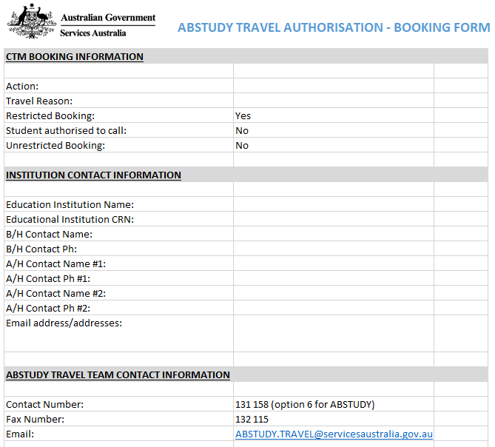

This screenshot is only an example.

## CTM booking information

To complete this section, follow these steps for each field:

1. In the box next to **Action**, choose one of the options available from the drop down list:

* **Booking** – for new travel requests.
* **Amendment** – to amend existing booked travel
* **Cancellation** – to cancel existing booked travel
* **Reimbursement** – for bulk reimbursement requests.

1. Next to **Travel Reason**,choose one travel reason from the drop down list:

* **Away from Base** – to book travel for a student studying through distance education to attend face-to-face lectures or tutorials on campus, and to access all campus facilities in a residential school
* **Compassionate** – to book travel for medical reasons or funerals where a student needs to return home
* **End of Study** – to book end of study travel
* **End/Start of Year** – to book return travel over the Christmas holiday period
* **Orientation/Interview** – to book travel for school orientation purposes or for interviews
* **School Vacation** – to book travel for school vacation periods, except the Christmas break
* **Special Purpose** – to book travel for school activities, such as graduation, or for students that are homesick or at risk of suspension or expulsion
* **Start of Study** – to book start of study travel.

1. **Restricted Booking** –is set to **Yes** for secondary students and **No** for tertiary students
2. **Student Authorised to Call** – is set to **No** for secondary students and **Yes** for tertiary students
3. **Unrestricted Booking** – is set to **No** for secondary students and **Yes** for tertiary students.

## Institution contact information

This section asks for your contact details.

Phone numbers must be 10 digits long with no spaces or brackets. For example, 0291111444 or 0400123456.

To complete this section, fill in the following details for each field:

* **Educational Institution Name** – name of school, boarding institution or hostel
* **Educational Institution CRN** – school, boarding institution or hostel Customer Reference Number (CRN)
* **B/H Contact Name** – name of the relevant contact person during business hours
* **B/H Contact Ph** – phone number of the relevant contact person during business hours
* **A/H Contact Name #1** – name of the relevant contact person after business hours
* **A/H Contact Ph #1** – phone number of the relevant contact person after business hours
* **A/H Contact Name #2** – name of the relevant contact person after business hours
* **A/H Contact Ph #2** – phone number of the relevant contact person after business hours
* **Email address/addresses** – you can provide a maximum of 5 email addresses where travel itineraries will be sent. If there is more than one email address, please separate with a comma. For example abc@school.com.au, person@school.com.au, person2@school.com.au

## ABSTUDY travel team contact information

The information under this section is pre-filled and should not be changed.

No action required.

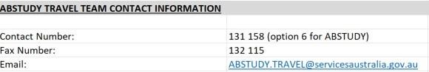

## Privacy notice

The booking information sheet must have the following privacy statement. It’s to make sure schools and boarding providers advise students and associated travellers that their details will be shared with the travel management company.

The information you provide us about students and associated travellers will be used by Services Australia to arrange travel. Please let students and associated travellers know that we'll share some of the information you provide with our authorised travel management company. This may include sharing information about family members, education representatives, community members and supervisors. More information can be found at servicesaustralia.gov.au/privacy

# How to complete the travel arrangements sheet

This sheet contains the details for each traveller's booking.



To complete this section, follow these steps for each field:

1. Below **Title** choose one of the following from the drop down list:

* Miss
* Mr
* Mrs
* Ms
* Master
* Dr.

1. Insert **Surname** – this will be the traveller's preferred name and the one used on their identification
2. Insert **First Name** – this will be the traveller's preferred name and the one used on their identification
3. Insert **DOB** – Date of Birth

You must use '/' between day/month/year so the date format is correct. For example, 01/02/2004.

Don’t enter 010204 as this will produce an incorrect date format.

1. **Traveller CRN** – A Customer Reference Number (CRN) is required for all travellers, including associated travellers linked to students. If the traveller does not have or remember their CRN, contact the National Business Gateway on **131 158**, option 6 for ABSTUDY, for assistance
2. **Traveller Type** –is used to decide if the student or associated traveller requires travel arrangements. Information about each traveller must be completed in the template for travel arrangements to be booked. Do not include this information in the **Comments** field

Select one of the following from the drop down list for Traveller Type**:**

* **Student** – for all student travellers who are physically travelling
* **Dependents** – for a partner or dependent child in certain circumstances
* **Family or Community Members** – for a parent or guardian, partner or family member for compassionate, orientation or special purpose travel
* **Supervisor** – for a parent or guardian, family member or education representative from the school or boarding institution to supervise the student. If a student requires mandatory supervision, then a supervisor must be included in the travel request
* **Companions** – for a companion to travel with a student who is sick, hurt or has a disability
* **Education Representative** – for education representatives to travel to communities for orientation or special purpose activities, such as student interviews
* **Notional Student Traveller** – when an education representative, family or community member is travelling independently under the student's ABSTUDY entitlement. For example, a family member is travelling to the school for a graduation ceremony under special purpose travel. As the education representative, family or community member is accessing the student's Fares Allowance entitlement, a travel booking is still required on the student's record. This is known as a 'Notional Student Traveller' booking.

In the Booking form, add a travel request for the student, using 'Notional Student Traveller' as the Traveller Type. No travel dates need to be provided in the booking form, as the student is not physically travelling with the education representative, family or community member.

Identify that the bookings require linking by entering **Yes** in the **Linked Travellers Reqd** column. Refer to screenshot under the **Linked Travellers Reqd** heading below.

Services Australia requires two emergency names and phone numbers for every traveller's booking.

1. **Emergency Name #1** – Name of the first emergency contact. This person will be contacted in the event of an emergency or travel disruption. For students who have a Safe Travel Plan (STP), this person will enact the STP
2. **Emergency Ph #1** – Phone number of the first person to be contacted in the event of an emergency, such as a travel disruption - must be 10 digits long, no spaces or brackets, for example 029111444 or 0400123456
3. **Emergency Name #2** – Name of the second emergency contact. This person will be contacted in the event of an emergency or travel disruption if the primary contact is unavailable. For students who have a Safe Travel Plan (STP), this person will also enact the STP
4. **Emergency Ph #2** – Phone number of the second person to be contacted in the event of an emergency, such as a travel disruption, if the primary contact is unavailable - must be 10 digits long, no spaces or brackets, for example 029111444 or 0400123456



This screenshot is only an example.

1. Insert **Travel Date and Return Date**

You must use '/' between day/month/year so the date format is correct. For example, 01/02/2004.

Don’t enter 010204 as this will produce an incorrect date format.

Enter the first day of travel, and return date.

1. **State/Territory** –in the drop down list selectthe relevant State or Territory the traveller is travelling from and to using the options available:

* NSW
* QLD
* ACT
* NT
* WA
* SA
* TAS
* VIC

1. **Travel From and Travel To** – once a State/Territory is selected from the **From State/Territory** and **To State/Territory** columns, it will allow you to select from a list of towns and communities available within that State/Territory. If the town or community is not available in the list, select **Other** and note the location where they are travelling from or to in the **Comments** column. Services Australia will periodically update the options.
2. **Safe Travel Plan** – applies to all primary and secondary students under 18 years of age and is mandatory from 1 July 2019 for pre-booked travel arrangements. From the drop down list, select either:

* **Yes** – select if a Safe Travel Plan is in place for the student
* **No** – select if a Safe Travel Plan is not in place for the student. This option is also used for Notional Student Travellers, and associated travellers such as supervisors who do not require a Safe Travel Plan.

1. **Linked Travellers Reqd** – use to indicate whether the traveller will be travelling with another person. For example, a parent is supervising a student. Both the student and parent will have their travel details entered on the **Travel Arrangements** sheet, and **Yes** selected in the **Linked Travellers Reqd** column. The bookings can then be linked on the **Linked Travellers** sheet - see the **Linked Travellers Sheet** section below.



This screenshot is only an example.

1. **Travel Mode** – from the drop down list select one of the following types of travel:

* Air
* Bus
* Charter
* Rail
* Sea.

1. **Comments** – use the **Comments** field to enter any information about the travellers request such as:

* Transfers
* Meals
* Accommodation
* To/From travel locations if listed as **Other** in the **Travel From** or **Travel To** columns.

If there’s a requirement for a particular supplier, you must include the reason in the comment section for us to consider it.

The comments field should not be used to advise of associated travellers linked to one or more students. Please use the linked travellers sheet to link students to associated travellers.

# How to complete the linked travellers sheet

Use this sheet to advise of travellers who will be travelling together. It always needs to be completed if one or more of the students on a booking is being supervised during travel.

**Traveller 1 and Traveller 2 fields** - these fields consist of a drop down menu containing a summary of the booking information entered on the **Travel Arrangements** sheet. Booking information will only be displayed for bookings that have **Yes** entered in the **Linked Travellers Reqd** column.

Travellers that will be travelling together need to be linked to ensure that their journeys are booked together.

To link two traveller's bookings, select the first booking in the **Traveller 1** column, and the second booking in the **Traveller 2** column.

Multiple links may need to be entered. For example, where a supervisor is travelling with several students, each student booking will require a link to the supervisor's booking, as shown in the screenshot below.



This screenshot is an example only.